DATA visualisation

By O. Asia Enyioma

Contents

Induction 2

Legislation 2

Task 1: Data and Data Structures 3

Task 2: Development of Data sets using Excel 7

Task 3: Introduction to Tableau 8

Task 4: Introduction to Dashboards using Power Bi 9

Conclusion 10

References 11

# Induction

In today fast pace world, we accumulation information in many different ways. This information either transmitted or store. There is five billion people around the world use the internet today. Internet users continue to grow. We know this by the data information that has been collect in many diverse ways.

There many ways of collecting, storing and reporting data, depending on the type of data been stored, the information has been essential for many companies to improve on their product or services.

**Why is data valuable today?**

Many companies has improved because of the data reports. They have created reports that benefits companies by providing insight into customer’s behaviours or the market conditions before they starting or progressing in the business. Data visualization has developed into a crucial business skill that may assist turn data into insights that can lead to significant business outcomes and better customer experiences. The majority of firms today have many data from various parts of their businesses, but they are unable to perceive how this data might aid in better decision-making, actions, and outcomes.

# Legislation

As part of the GDPR laws, it is important that data must be protected the company. The General Data Protection Regulation (GDPR) is a legal framework that sets guidelines for the collection and processing of personal information from individuals who live and outside of the European Union (EU).

This legislation, it has been approved in 2016. The GDPR went into full effect two years later. Its aim is to give consumers control over their own personal data by holding companies responsible for the way they handle and treat this information. The regulation applies regardless of where the business is base on, which means that the website must comply the act that is attract European visitors, even if they do not specifically market goods or services with EU residents.

There are several ways for companies to become GDPR-compliant. Some of the key steps include auditing personal data and keeping a record of all the data they collect and process. Companies should also be sure to update privacy notices to all website visitors and fix any errors they find in their databases.

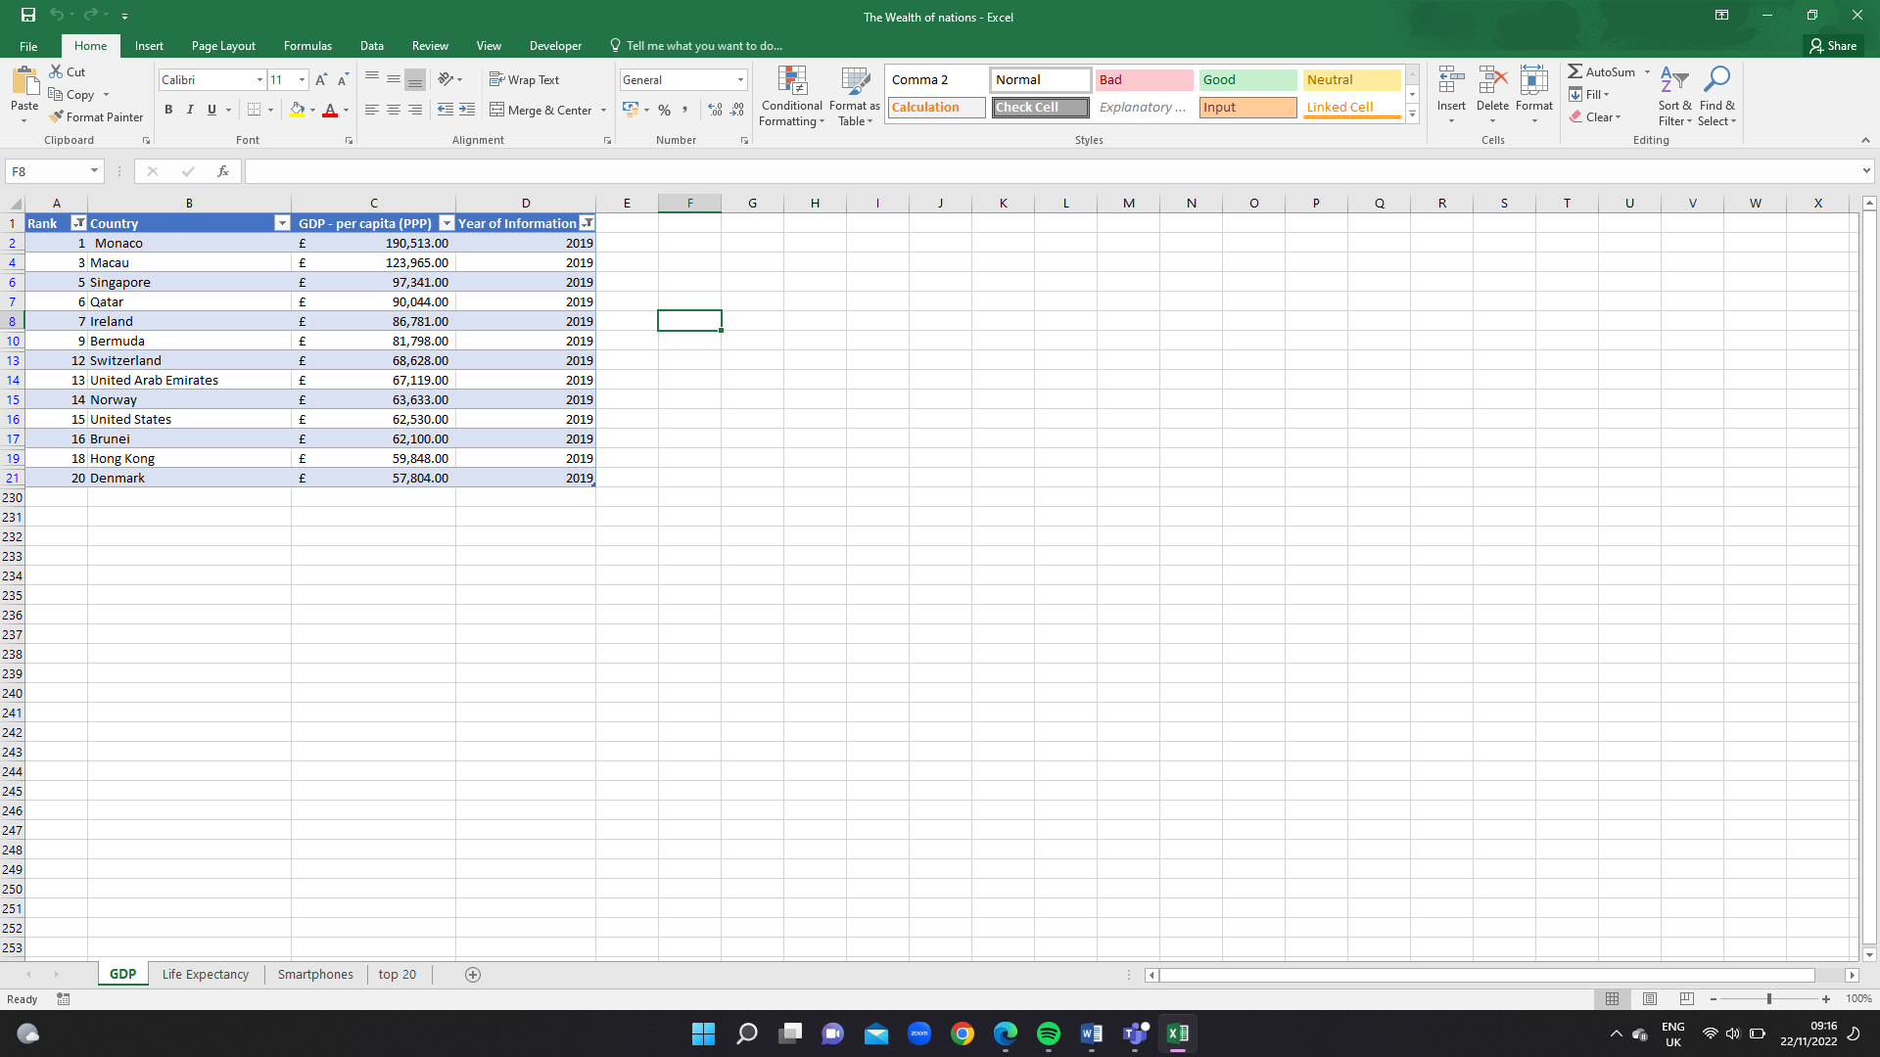

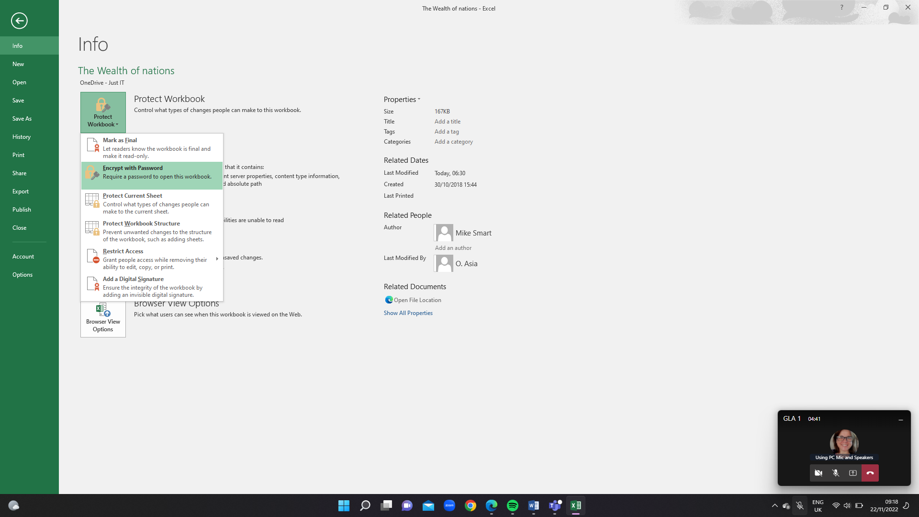

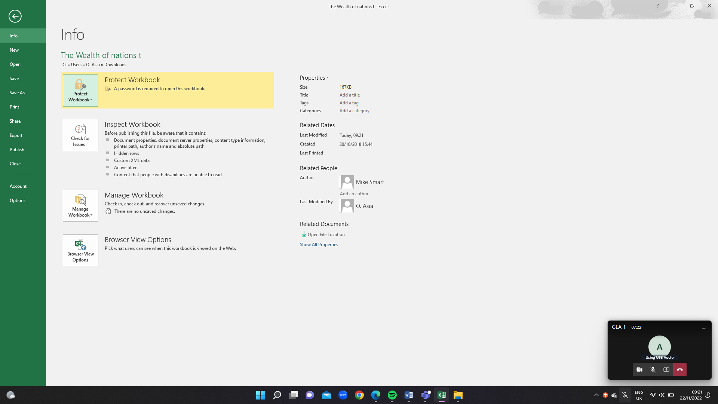

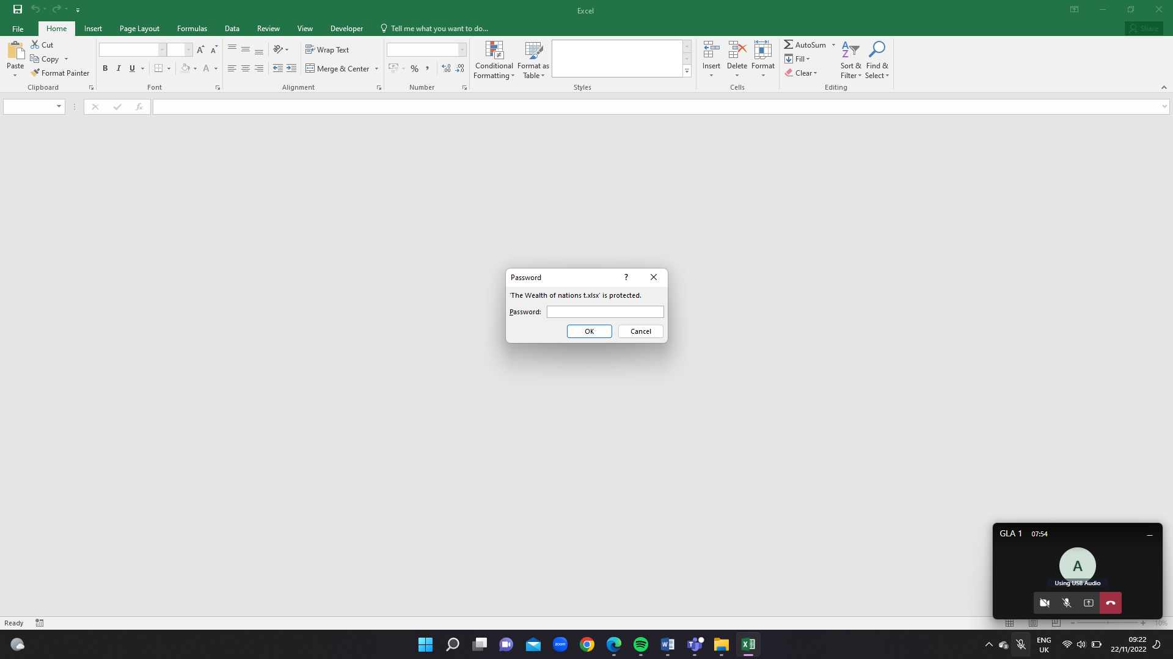

# Task 1: Data and Data Structures

What is data?

Data is a collection of facts and statistics gather information together for the analysis. Nowadays, it is mostly often stored in a digital format thanks to advancements in computer programs that can store large volumes of information. Data is not only in digit it can be in any forms to help with decision-making.

External Data:

External data focuses on analysing trends relating to consumers, competitors, markets, and suppliers. External sources, trade associations, government, and trade publications also fall under this category.

Marketing:

Marketing data pertains to information about customers and their behaviours and preferences, which is to target specific individuals with tailored messages. This type of data may include the various ways customers interact with your company, such as social media activity, web cookies, and advertising retargeting.

Structural:

Structural data is a way to organise and design or redesign physical infrastructure, such as blueprints that show how structural elements.

* Linked Lists

A linked list is a sequence of items arranged in a linear order all connected to each other. This means you must access data in order, so random access to data is not possible.

Each element in a linked list `1called a “node and each node contains a key and a pointer. The pointer directs you to the next node, called a “next.” The sequence starts with a “head,” which directs you to the first element within the list. The last element of this list known as the “tail.”

I can create a singly linked list, which lets you traverse each item in a forward direction from the head to the tail. Similarly, you can create a doubly linked list, which can traversed both forward and backward. In conclusion, you can create a circular linked list in which the next pointer of the tail points to the head and vice versa, forming a circle.

Linked lists are for symbol table management in switching between programs using Alt + Tab (On a PC).

* Stacks

A stack works almost exactly as it sounds. It is like stacking elements within a tall container.

Stacks known as LIFO (Last in First Out) structures. This means the element placed last can accessed first. You can “push” a new element onto the top of the stack, or you can “pop,” deleting the element inserted last, which is at the top of the stack.

Stacks are parsing and evaluating mathematical expressions and to implement function calls in recursion programming.

* Queues

A queue functions similarly to a stack, but instead of being a LIFO structure, it is a FIFO (First in First Out) structure. The easiest way to think about a queue is to think of a line of people waiting to enter a building. The person at the beginning of the line will enter the building first, while the person at the end will enter last

You can enqueuer an element in this structure, which means inserting the element to the end of the queue. You can also dequeuer an element, which means deleting an element from the beginning of the queue.

Queues are often used to manage threads in multithreading, and they are (not surprisingly) used to implement priority queuing systems.

Arrays

One of the simplest data structures, an array is a collection of items that are stored sequentially. An array contains values or variables—known as “elements”—of the same data type and is of a fixed size, so you cannot change the size of an array. Each item in an array is indexed starting with 0.

The best way to think about an array is like a weekly medication organizer. It includes small containers lined up in a sequence, and each container has elements inside.

Arrays commonly used as structures for building other, more complicated data structures. They also used for sorting algorithms.

Hash Tables

A hash table structure associates each value with a key and then stores them. This makes it easy to look up values efficiently using a key. It is an efficient way to insert and search for data regardless of its size, as it makes it easy to identify a specific object from a group of similar objects.

For example, if you go to college, you assigned a unique student ID number. This ID number is a key that can used to retrieve information about you and your student record.

A hash table uses what’s known as a “hash function” to map a data set of any size to one of a fixed size—the hash table. The values that a hash function returns known as “hash values.”

Hash tables - commonly used to create database indexes, to create associative arrays and to create a “set.”

Trees

A tree is a structure similar to a linked list because each item linked. However, in a tree items linked in a hierarchal fashion, just as you might see in a visual representation of someone’s family tree. There are various types of trees, each suited to different applications.

Binary search trees used in many different types of search applications.

Graphs

A graph is an abstract, non-linear data structure that is made of a finite set of nodes that connected by edges. The nodes may be referred to as “vertices” and contain values, whereas the edges are simply lines or arcs that connect two nodes in the graph.

Graphs often used to represent networks, such as circuit networks or even paths in a city. They are great for solving real-world problems, but they can also be as representations of digital networks.

For example, on Facebook, each user could represented with a node (or vertex). Each vertex could then contain information about that user, and each edge could represent their connection with another user.

Heaps

Similarly, a heap is a type of binary tree in which the parent nodes compared to their children. This allows the values within the nodes to arrange accordingly. Heaps can represented as trees, but they can also represented as binary arrays.

There are two types of heaps. In a min heap, the parent’s key is less than or equal to the keys of its children. In a max heap, the parent’s key is greater than or equal to the keys of its children.

Heaps often used in algorithms to create priority queues, and to find the smallest or largest value in an array.

# Task 2: Development of Data sets using Excel

In this part of that of my report I will walk through Excel. You will see how data can be easily stored in excel.

**What is Excel?**

Microsoft Excel is tool in the Office 365 suite. Excel is piece of software developed by Microsoft that uses formulas and functions to organize data and numbers using spreadsheets. The purpose for Excel is organising, storing, and working with data. Despite not being a database, Excel mostly used in data analytics and finance sectors to examine enormous amounts of data and generate visuals.

Excel Function

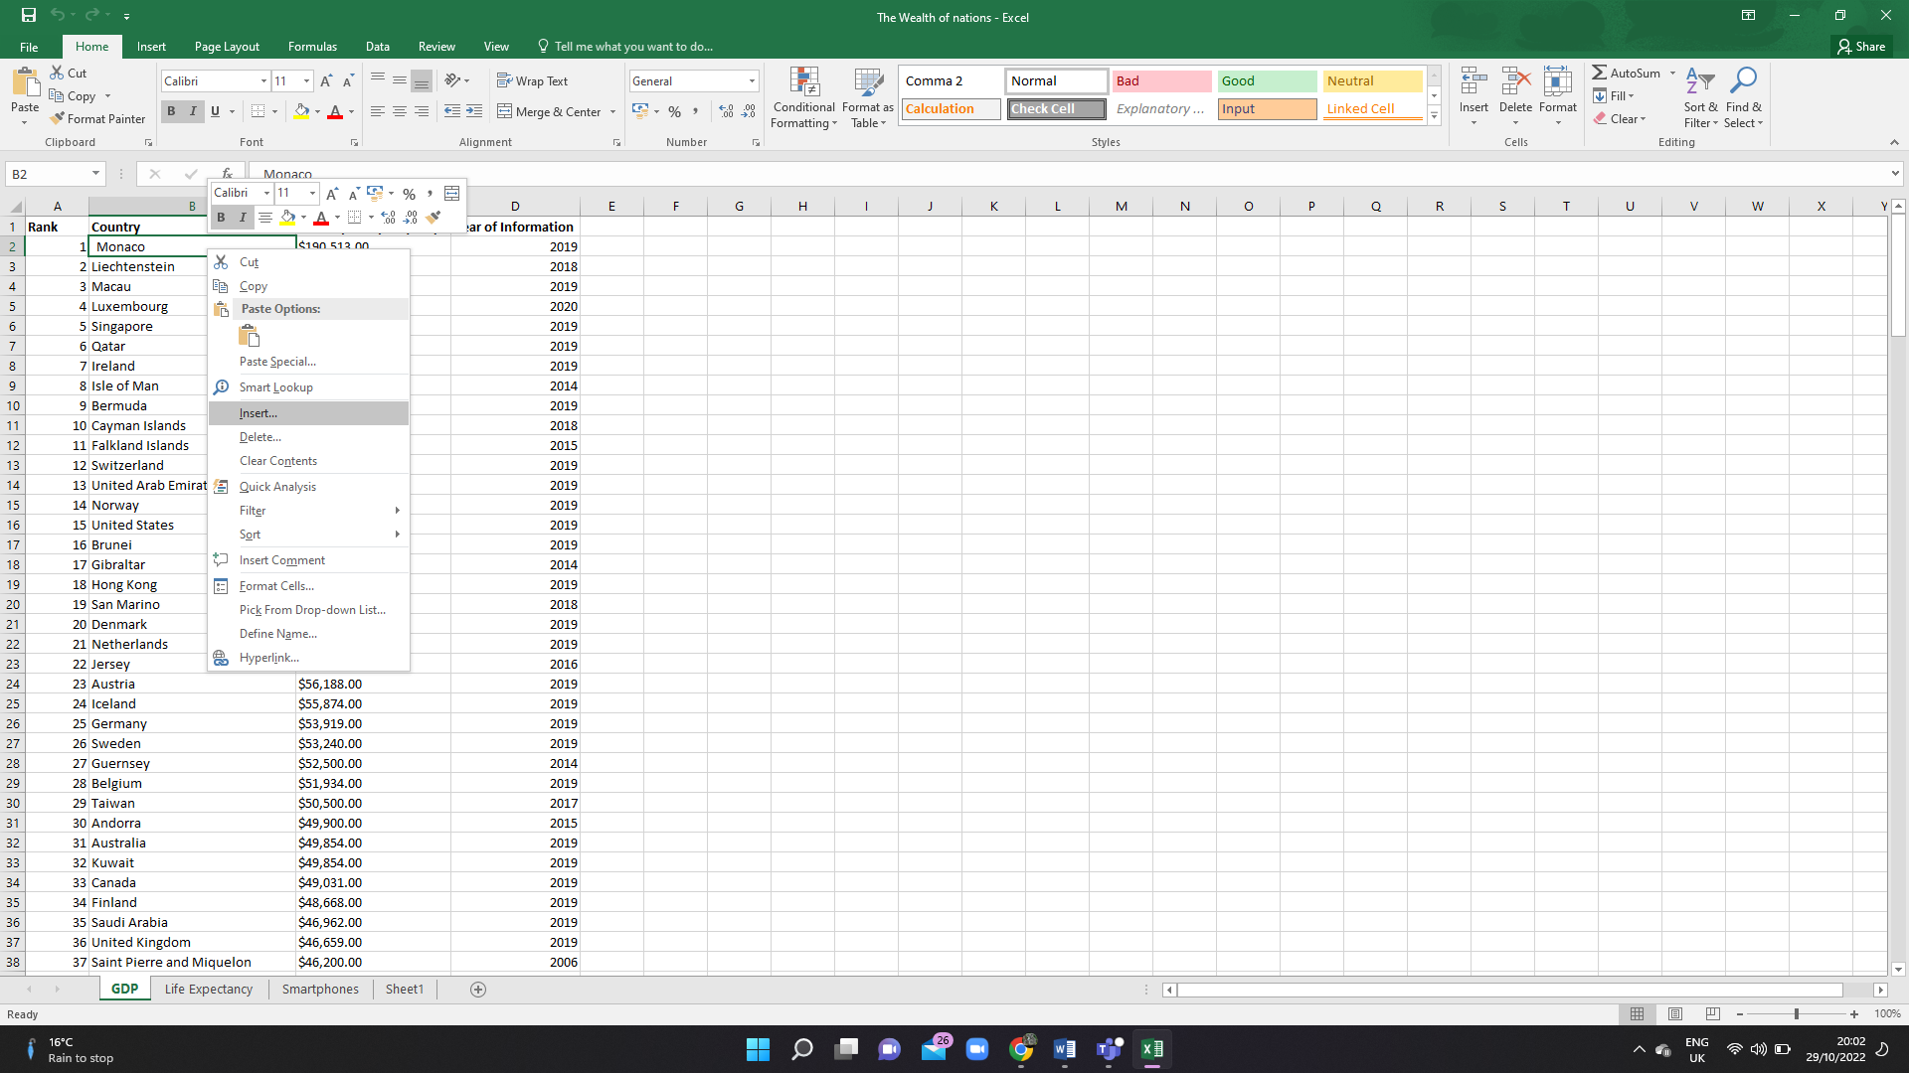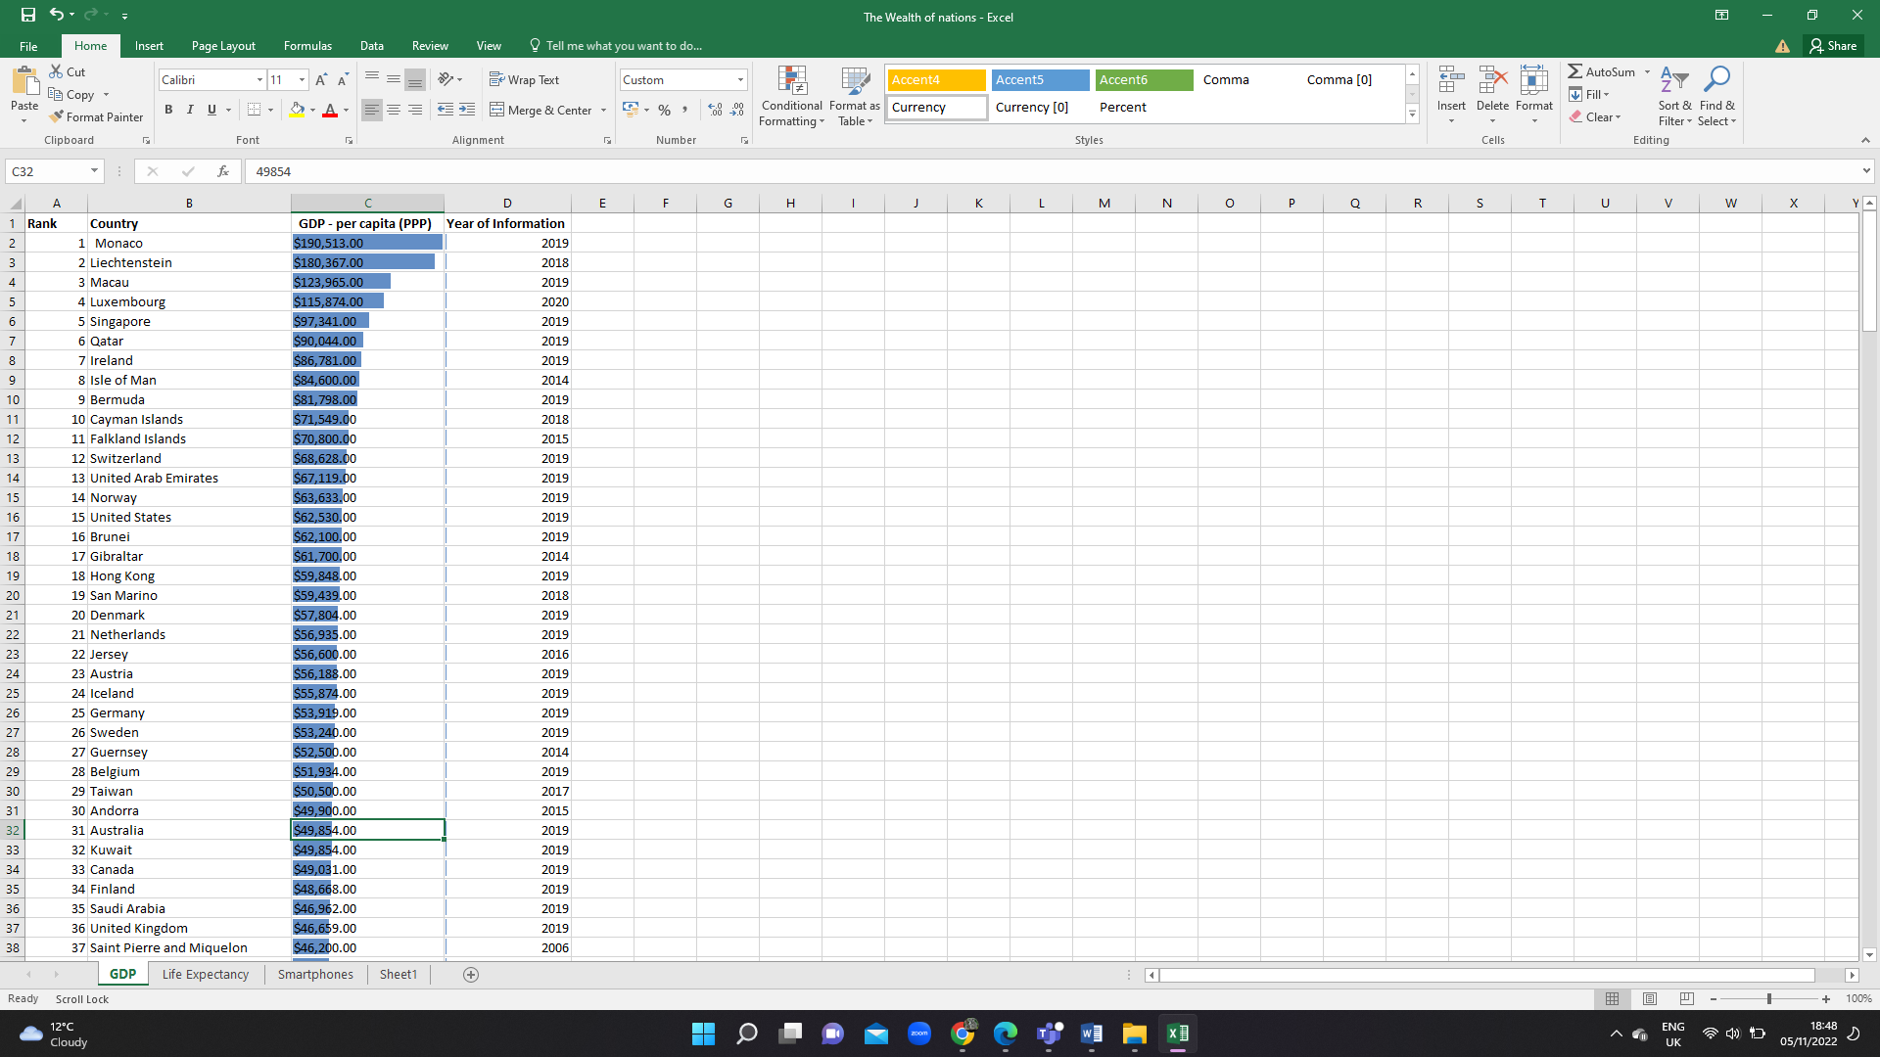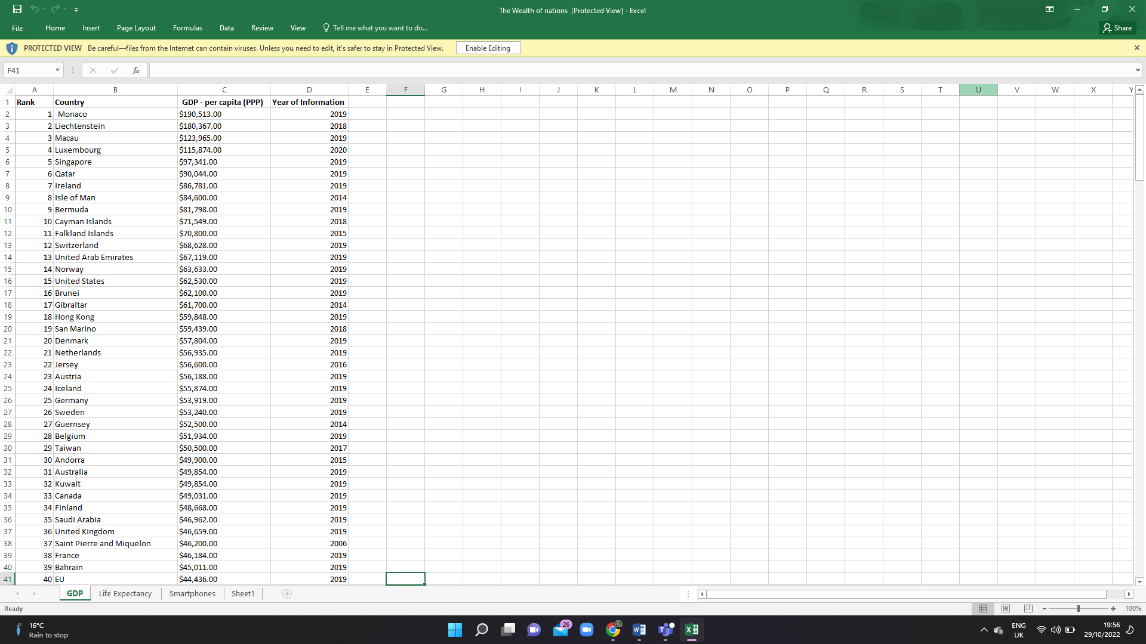

Can add, remove and clear the cell.

You can also filter, display a quick analysis and sort the sheet out

This called “cell”

The cell that I highlight is A1.

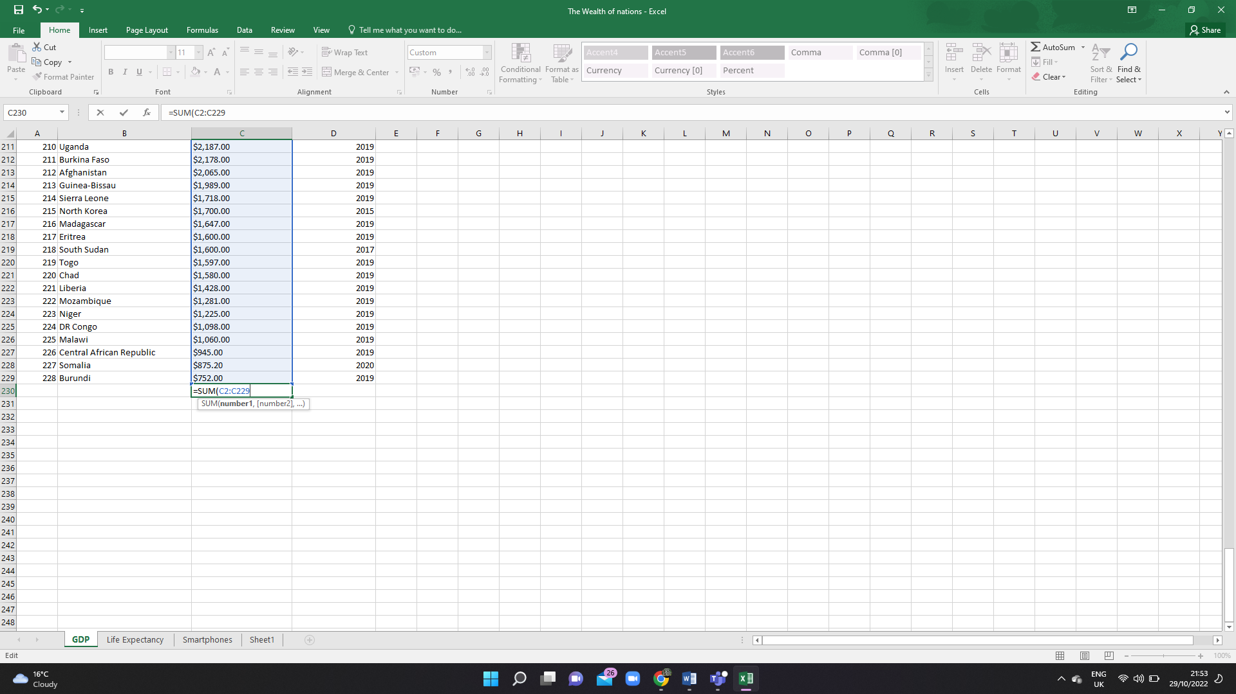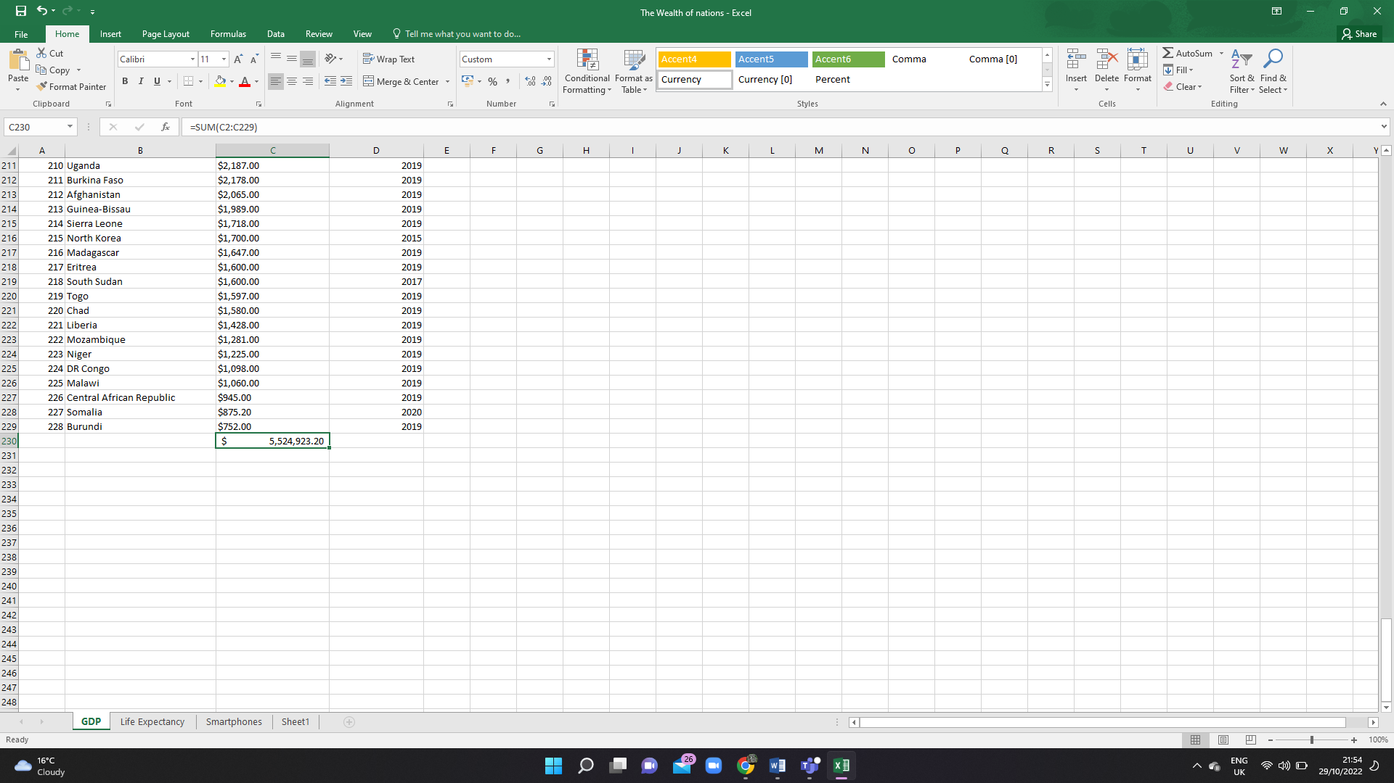

The highlighted boxes are the number that I want the excel to calculate

This is the total

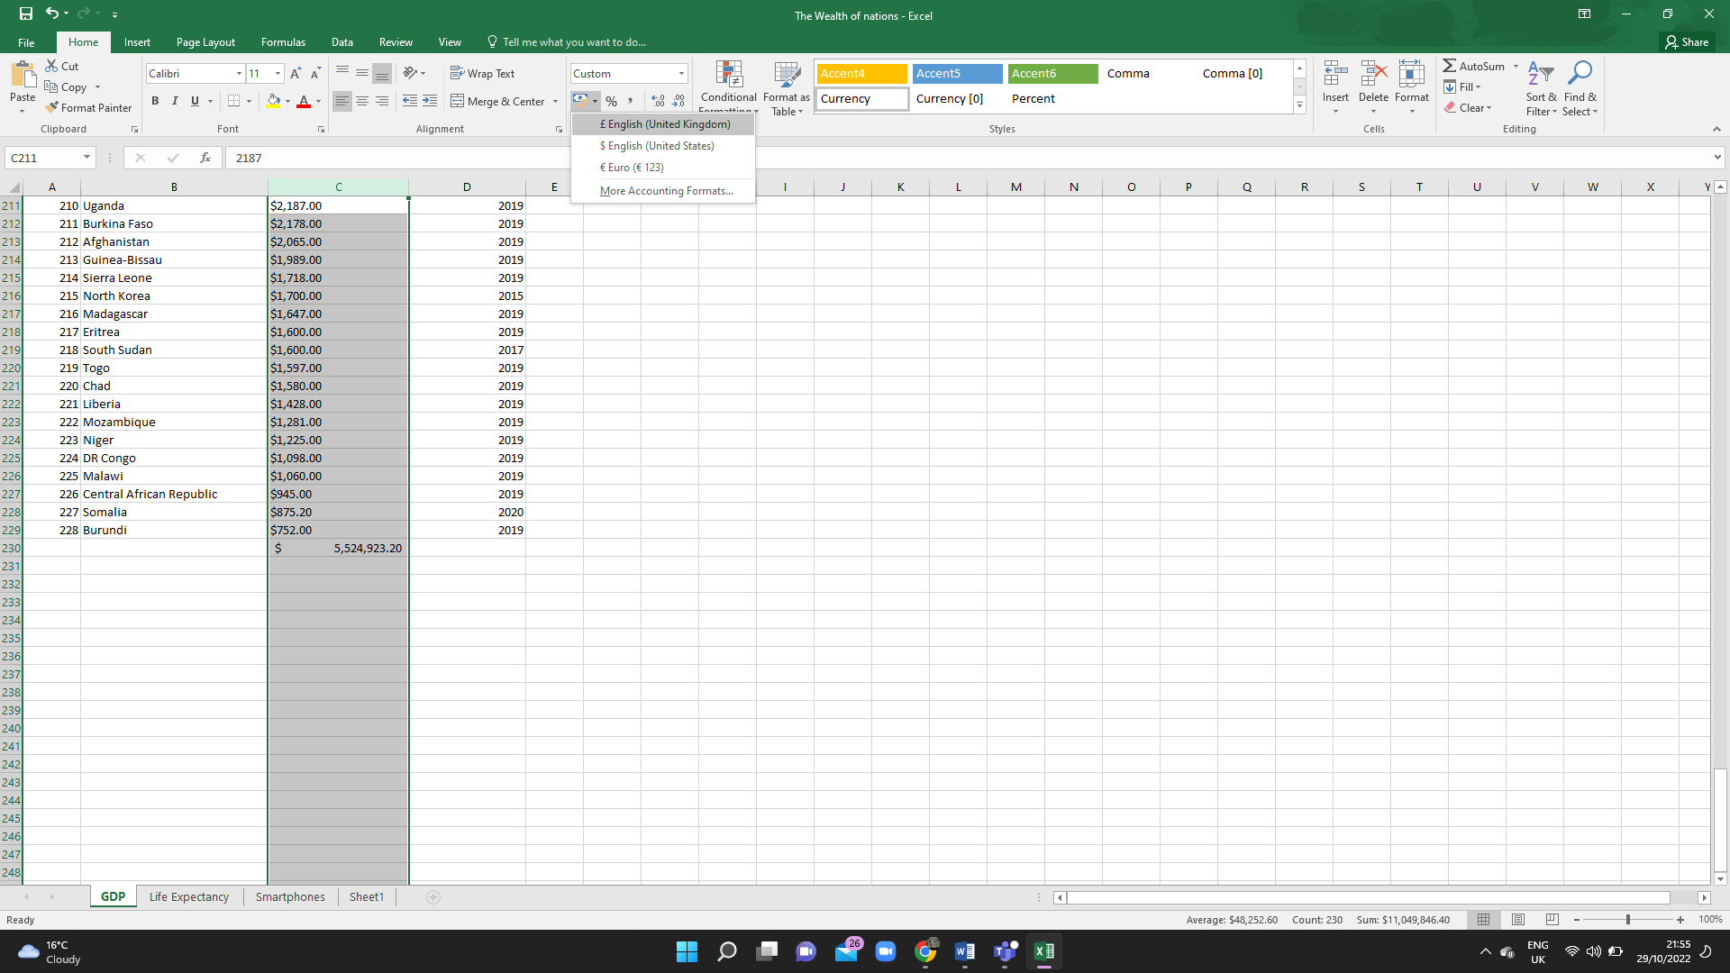

This function helps to cover the currency

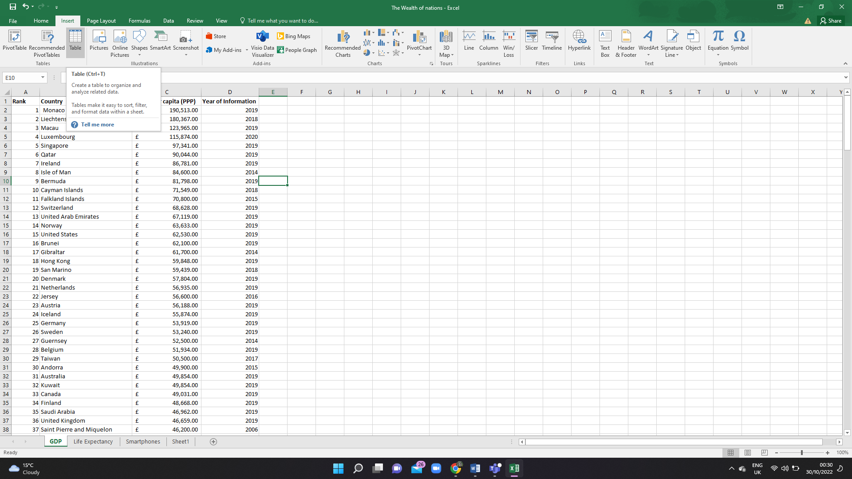

This function help me to create a table. I can also press Ctrl + T that does the same job.

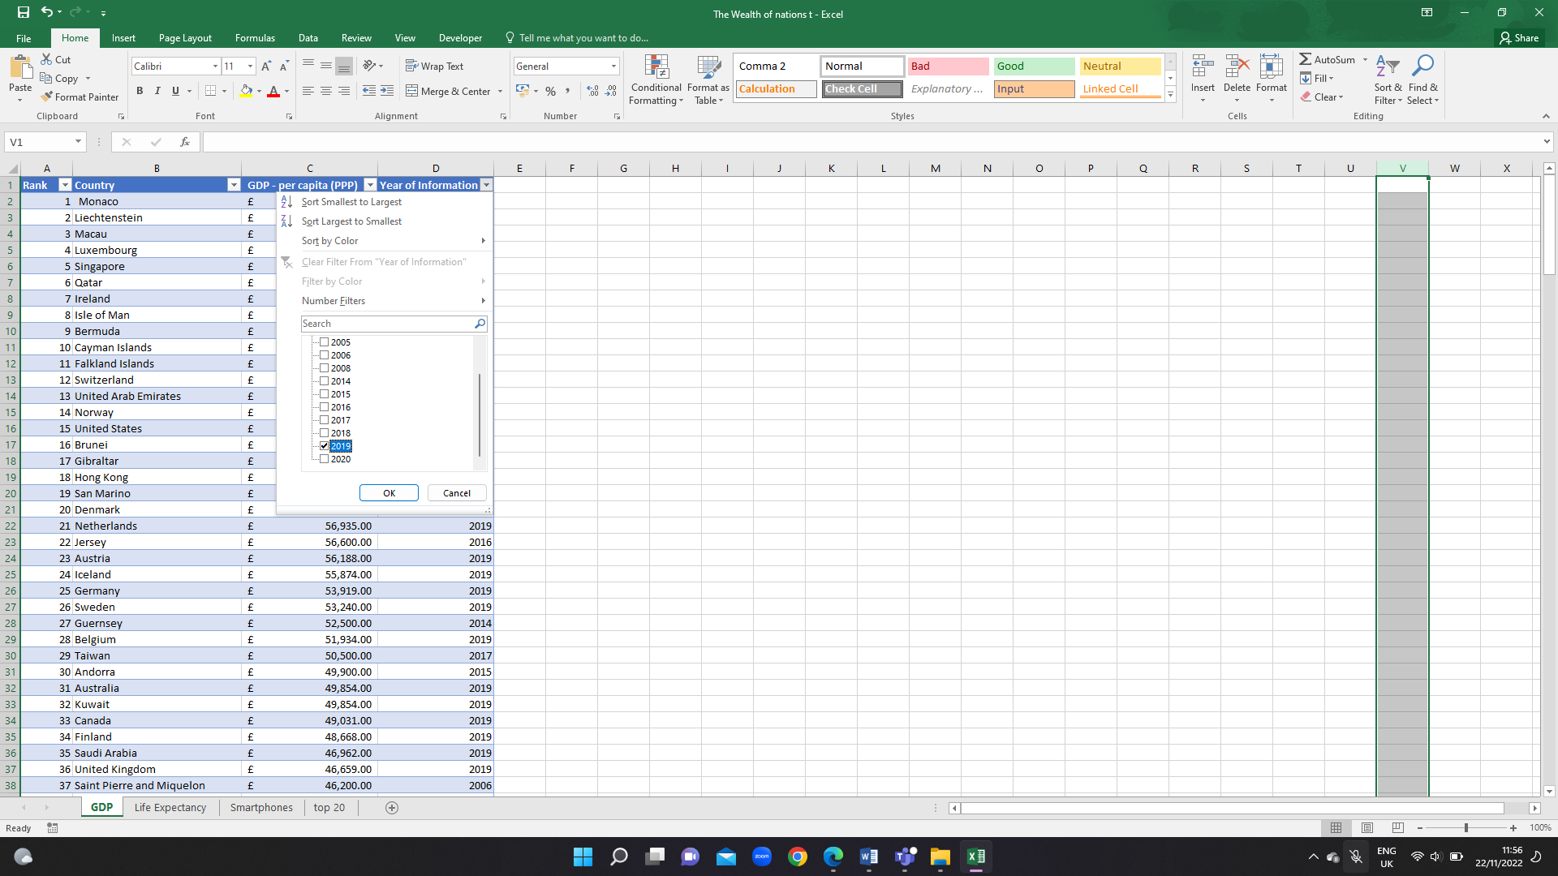

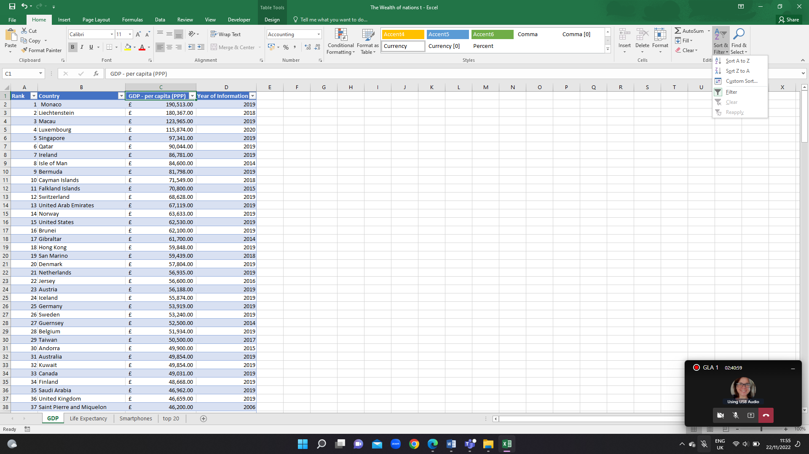

This function help find and sort the table quickly

When the filter setting come you can select the type of filter, you would like to see. The excel spreadsheet I shows the year I have selected.

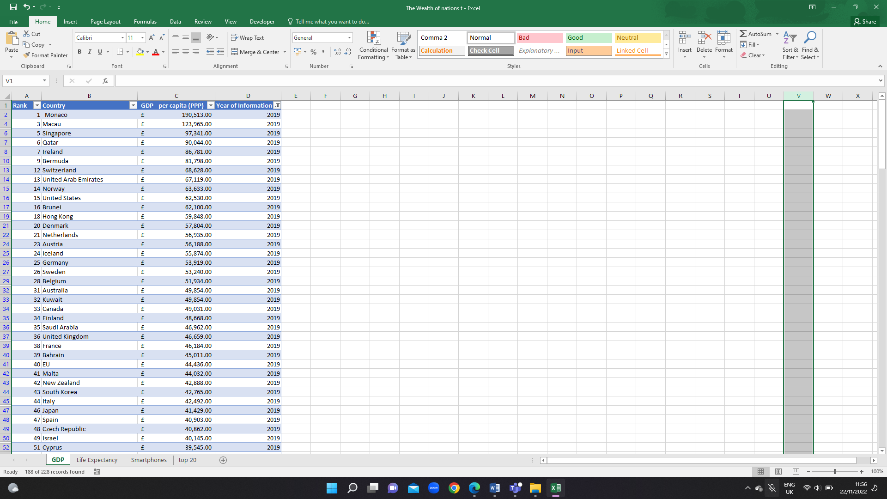

The excel spreadsheet I shows “2019”.

Charts

Charts are to display series of numeric data in a graphical format to make it easier to understand large quantities of data and the relationship between different series of data.

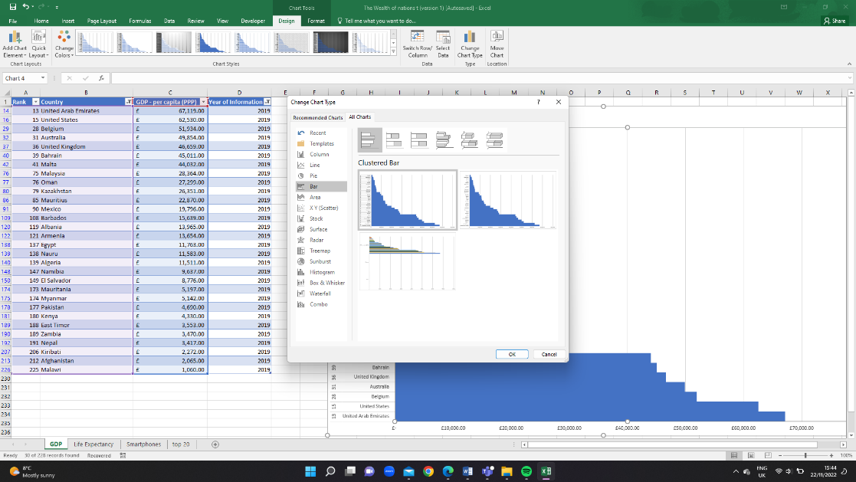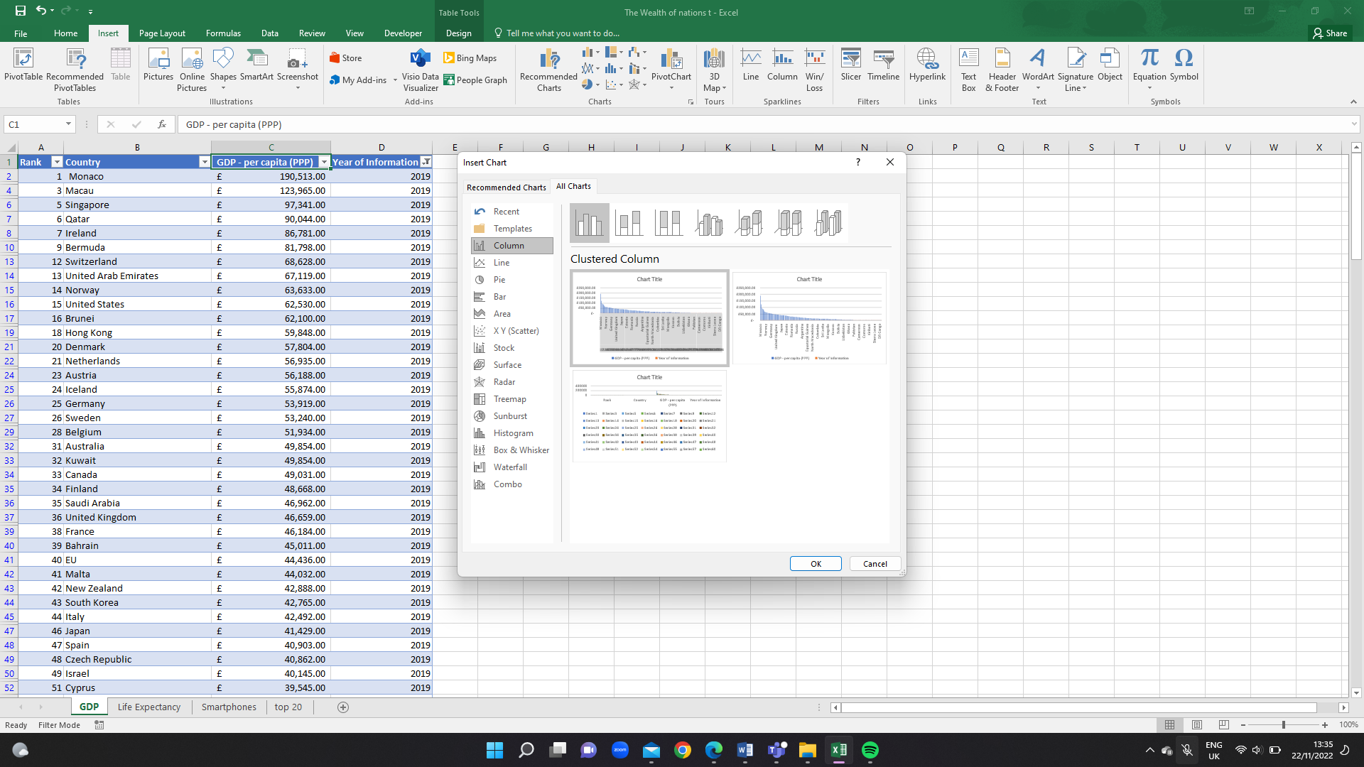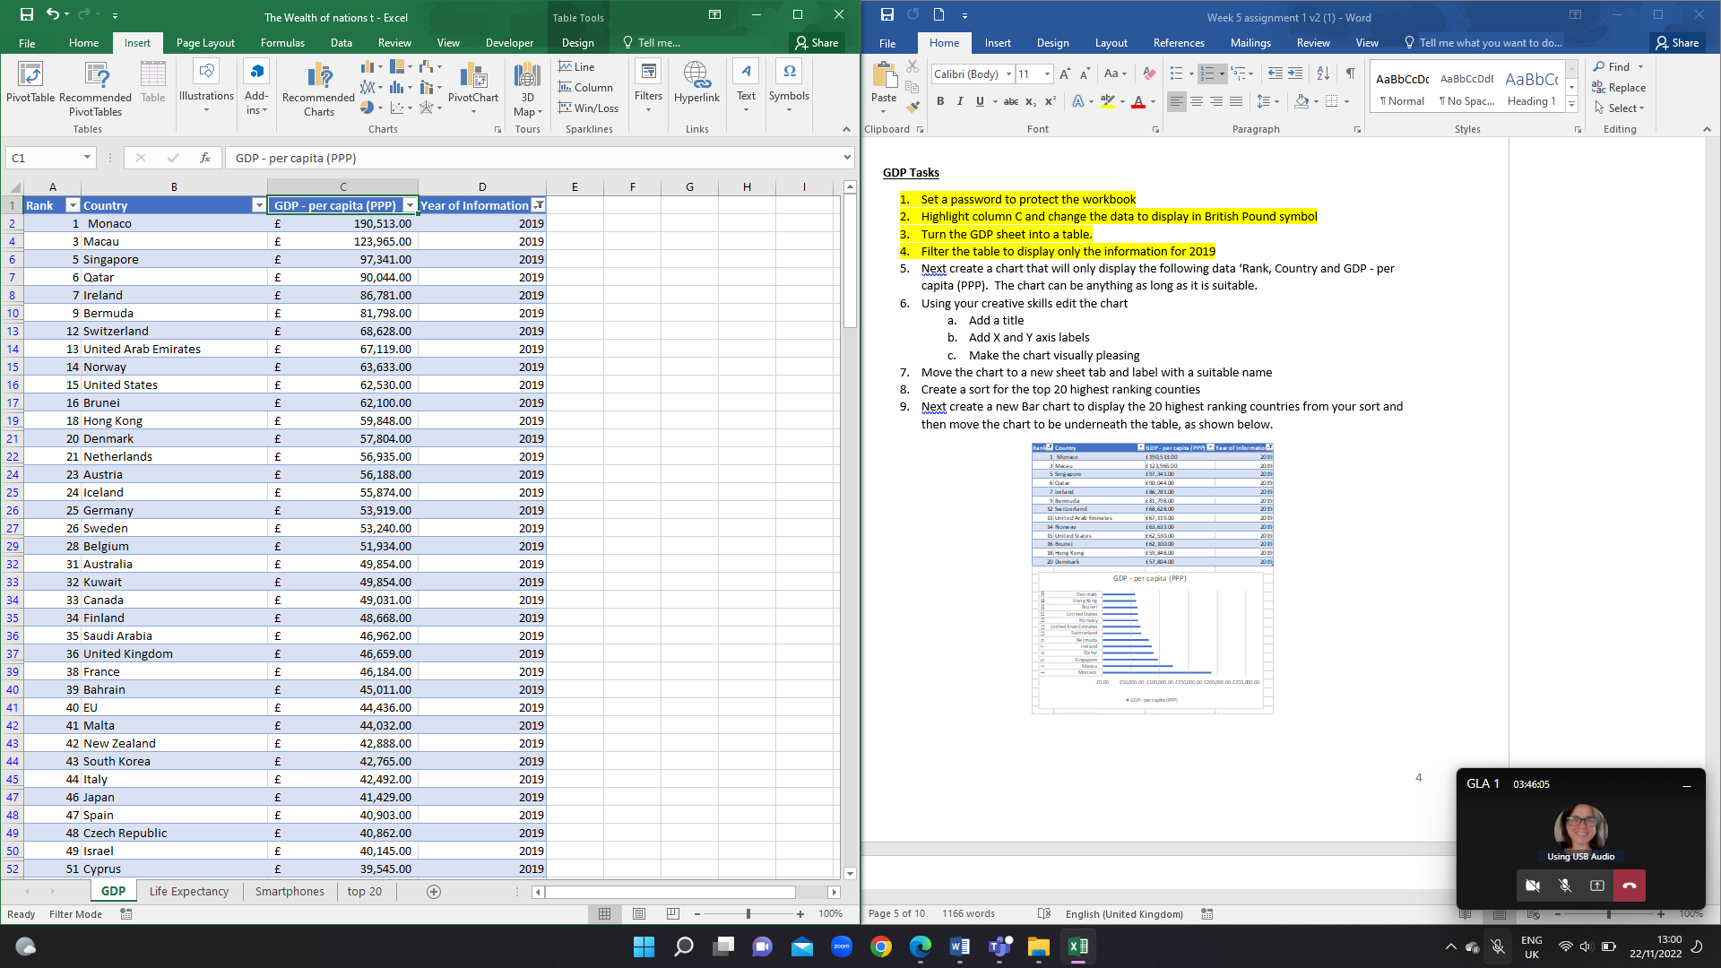

The chart is in “insert” tap.

This chart setting allows you to select the type of graphic format you would like your presentation to be. I select the “Bar chart”.

The purple and blue are the figures for the chart.

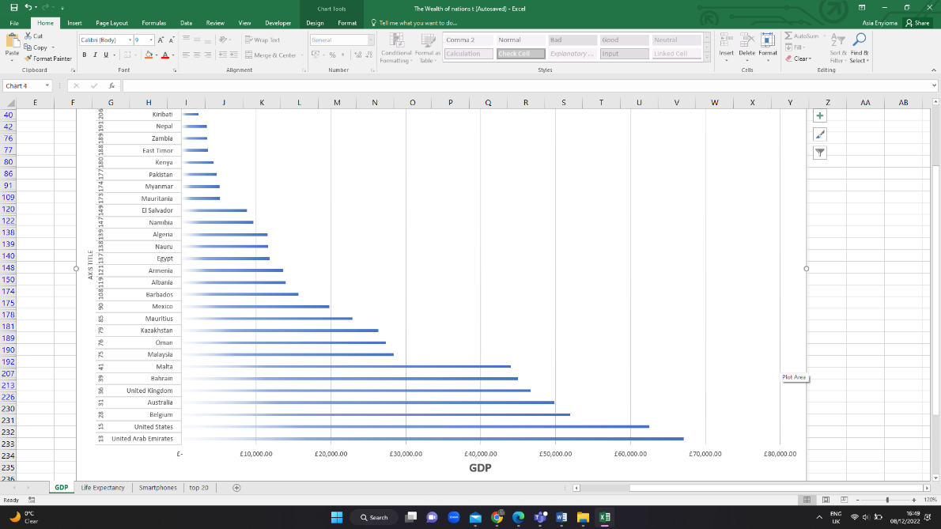

This is the final display.

**Micro**

A micro is a function that help with repetitive tasks.

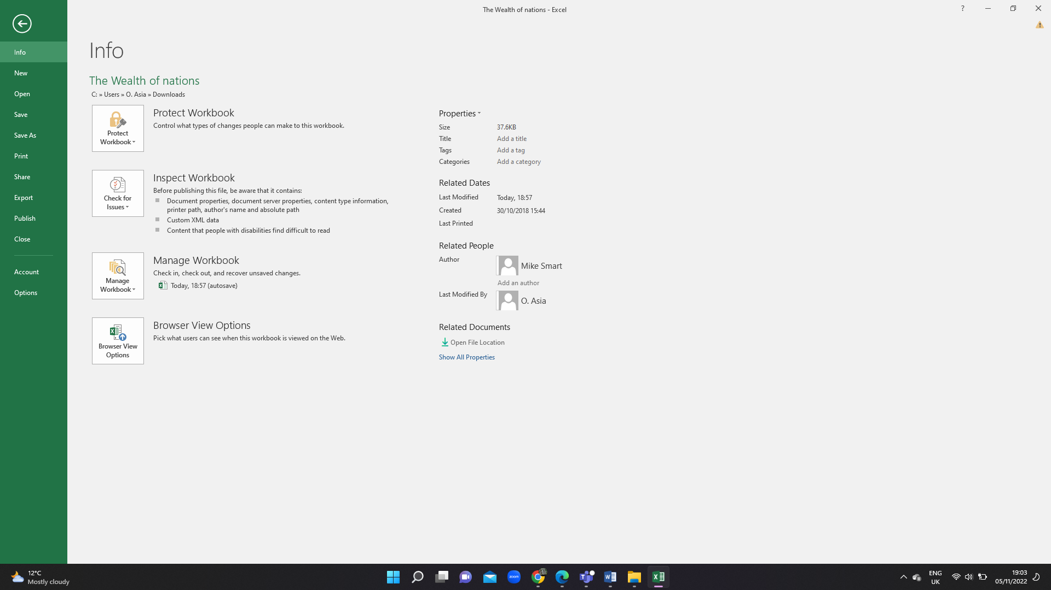

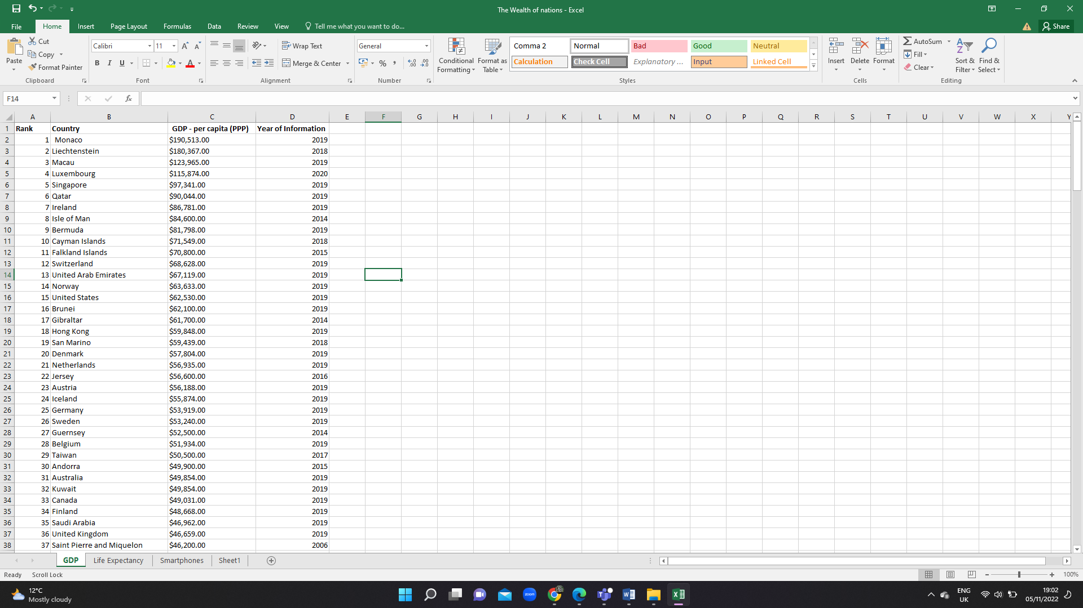

Then click to option

To create a micro you need to go to files

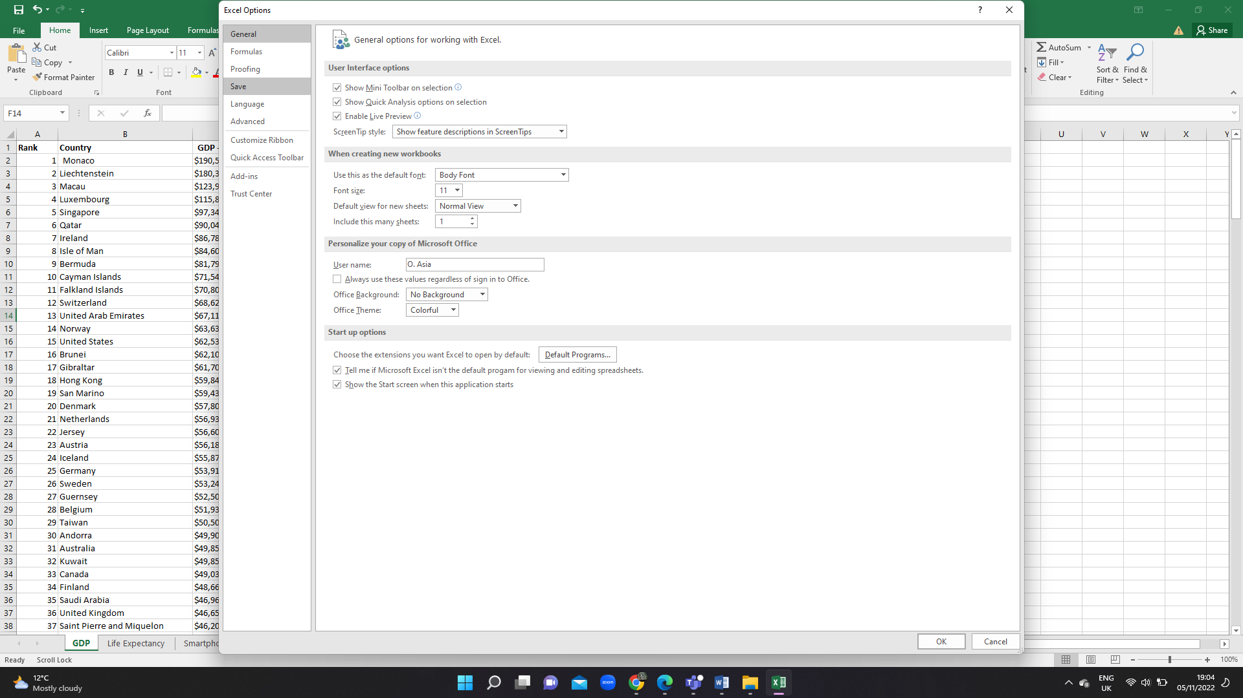

We are doing this step to ensure that the micro is activate in our setting.

We need to add development.

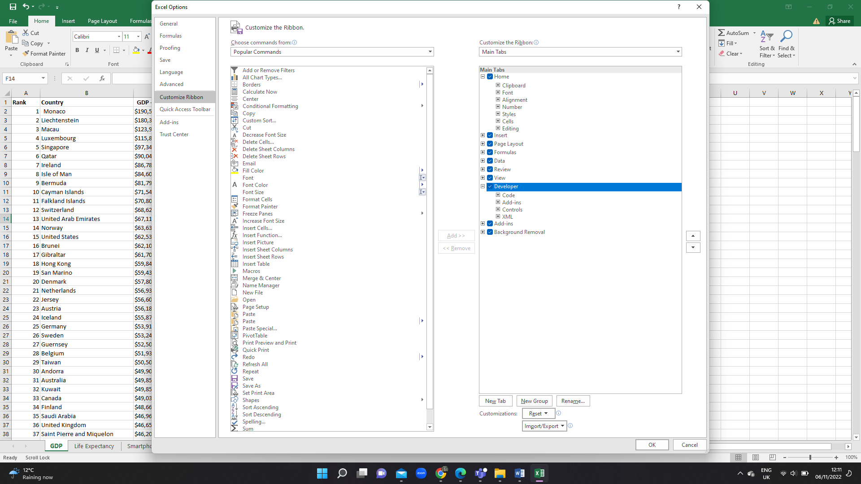

We add the development menu.

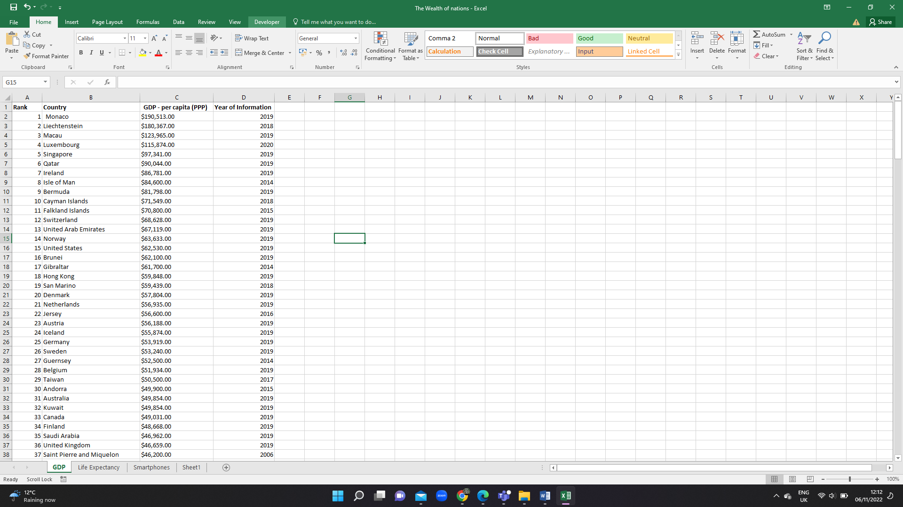

So now, we can see the development section

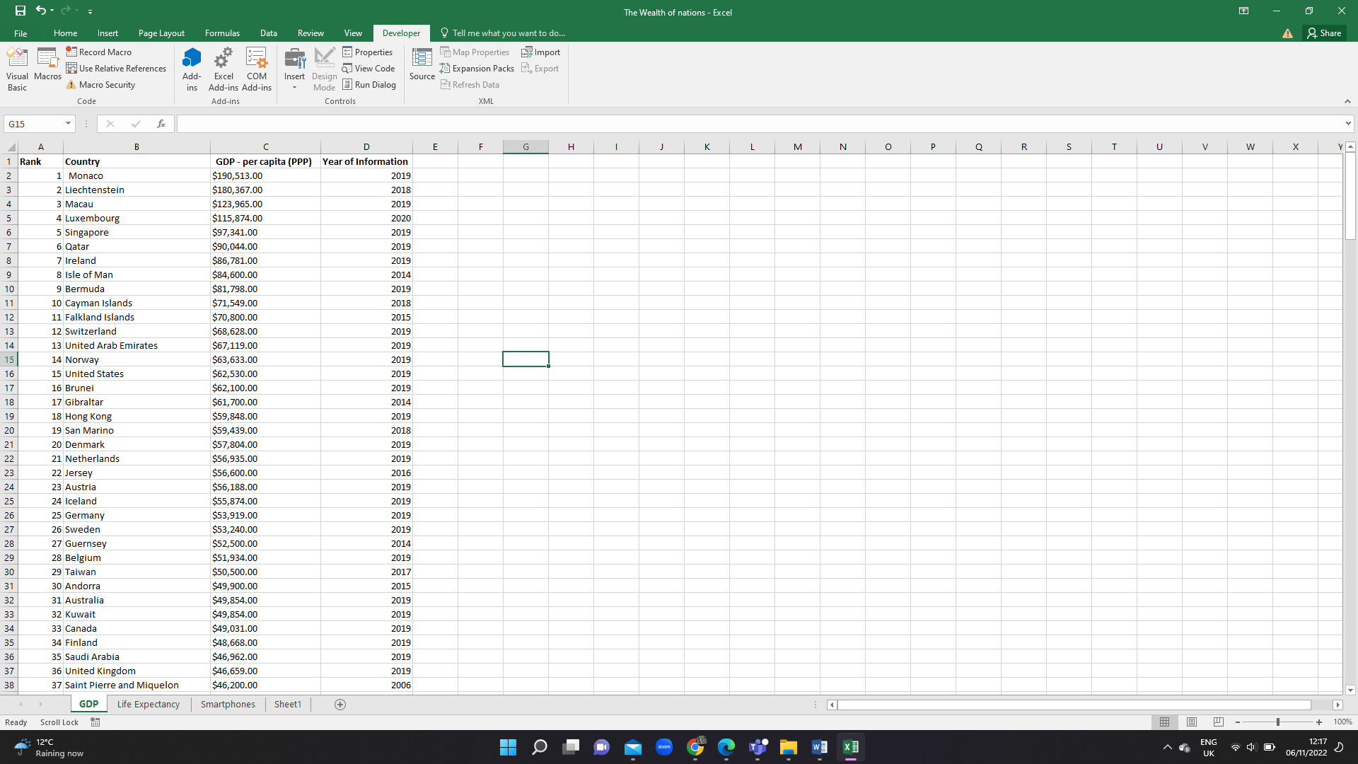

This function help me to create a table. I can also press Ctrl + T that does the same job.

l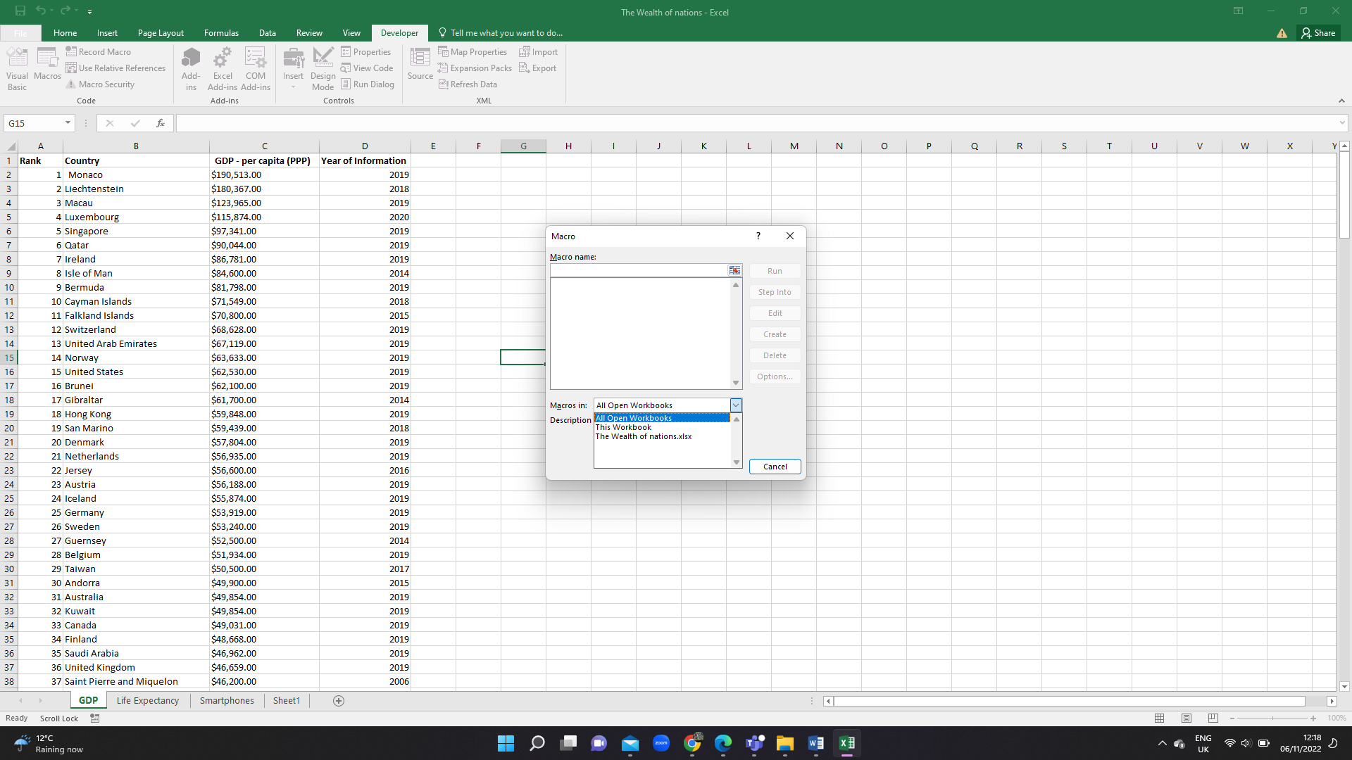

This box It let excel know which sheet you would like to work in.

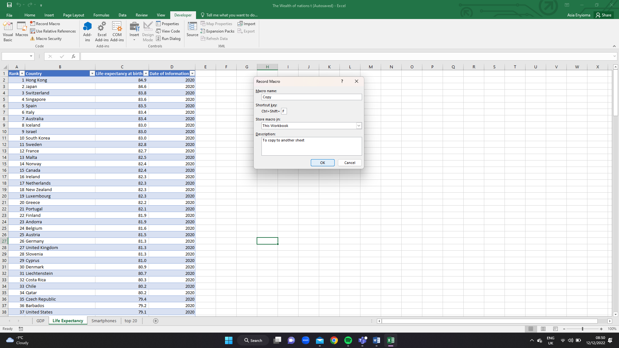

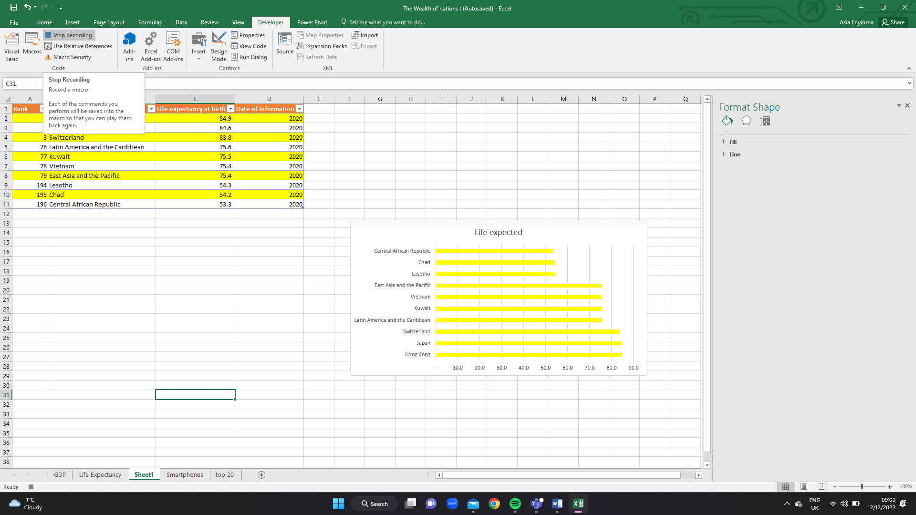

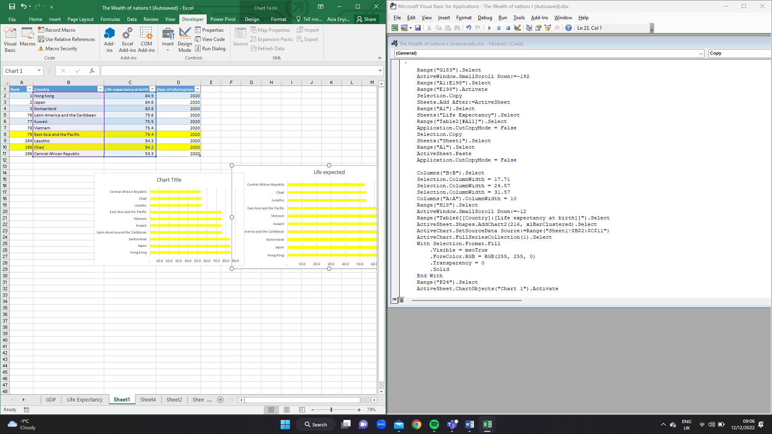

# Task 3: Introduction to Tableau

This in task I will introduce Tableau by using Tableau Public. The client requested that I take into account his or her colour blindness when creating my dashboard. Only the top 20 countries on the list are of relevance to the client. My entire collection of images should represent the top 20 ranked nations.

**What is Tableau?**

Tableau is a software provider that offers collaborative data visualization tools. Businesses use Tableau to show data, identify patterns for business intelligence analysis, and make the data easier to understand. While Tableau offers outstanding visualization capabilities that enable deeper insights and facilitate better decision-making across multiple sources of data, it additionally complements Excel, whereas Excel offers a familiar interface that businesses have used when building lightweight business applications for data.

Tableau function

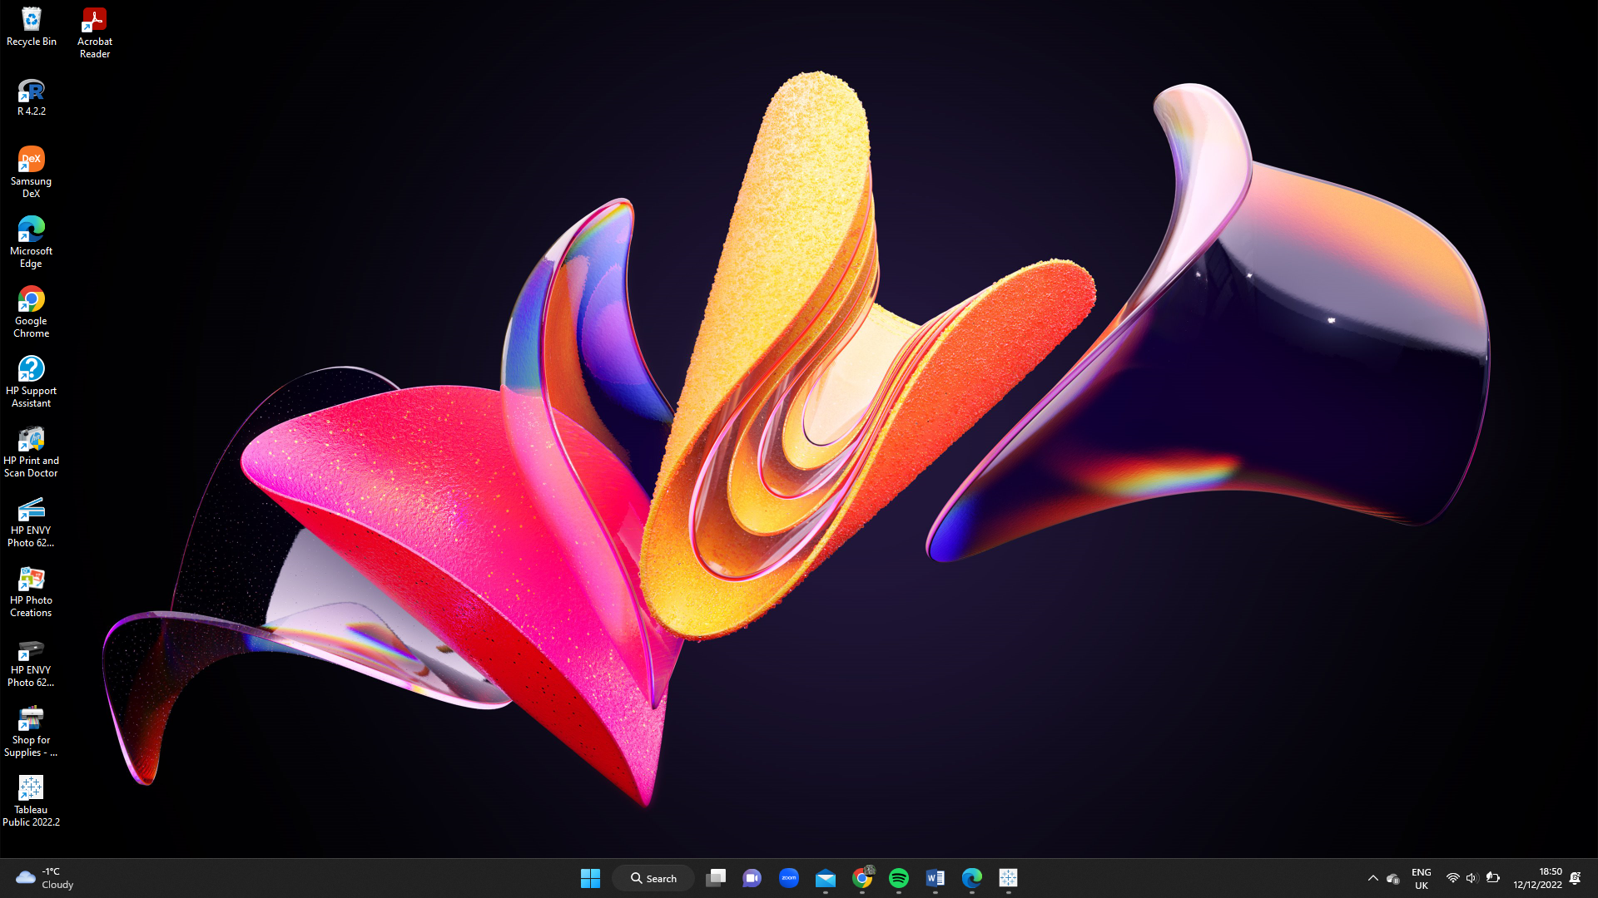

This tableau public software.

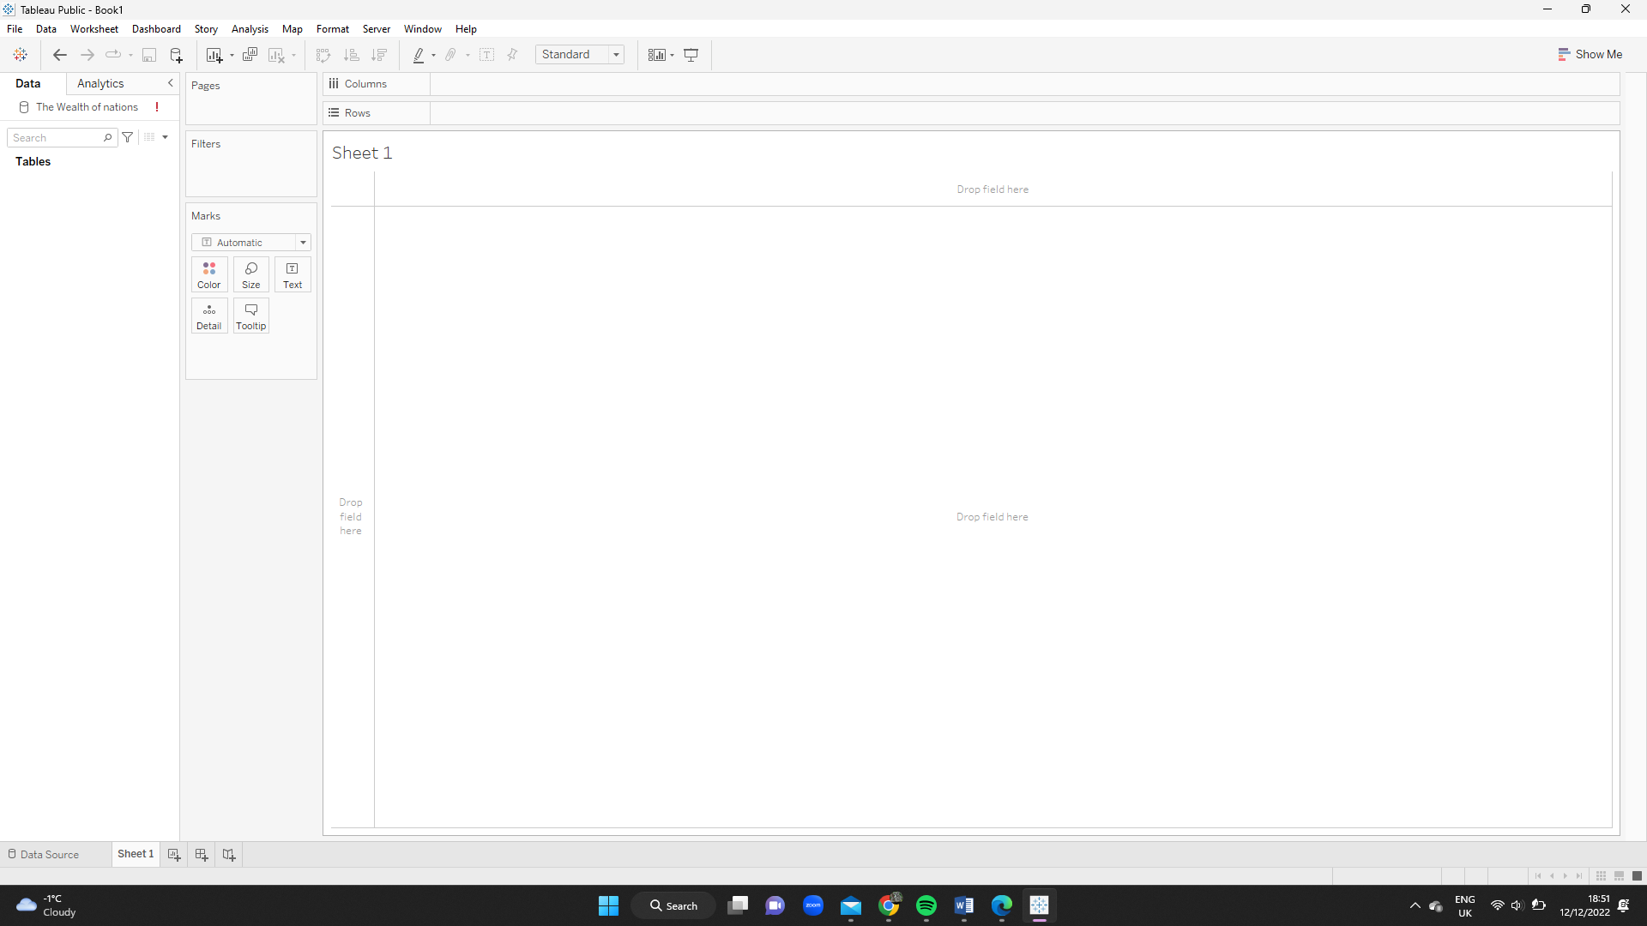

This is how tableau looks when you create a new project.

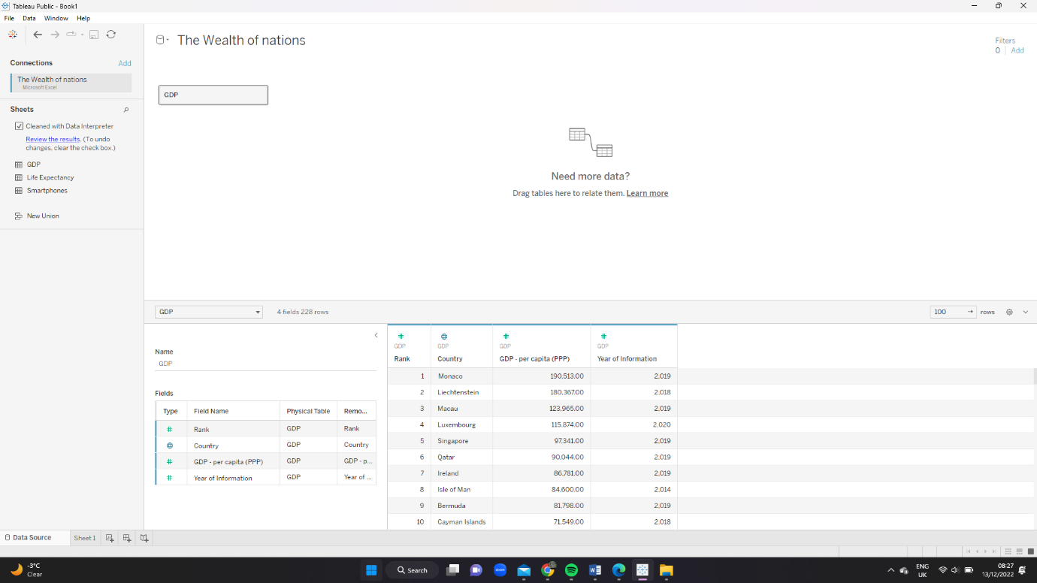

This is how it looks when you have inputted the data in the system.

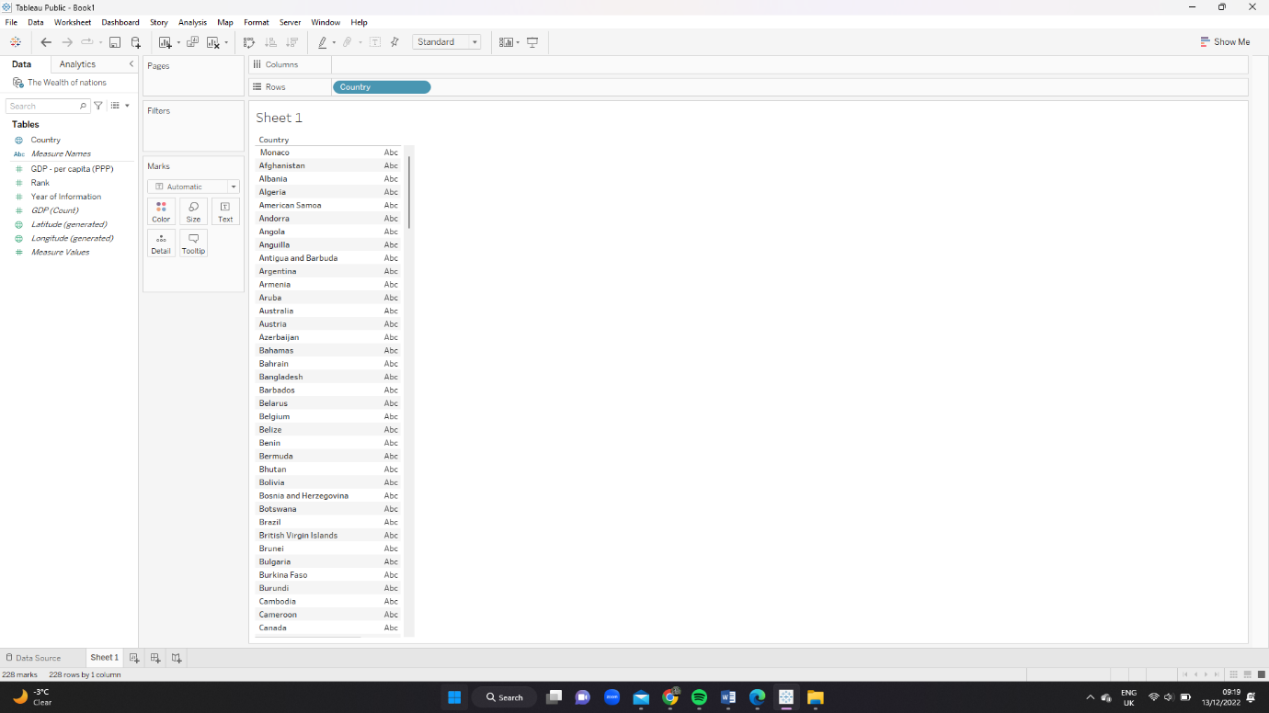

By dragging from the Table the country and sum to the column and rows, tableau was able automatically create the chart.

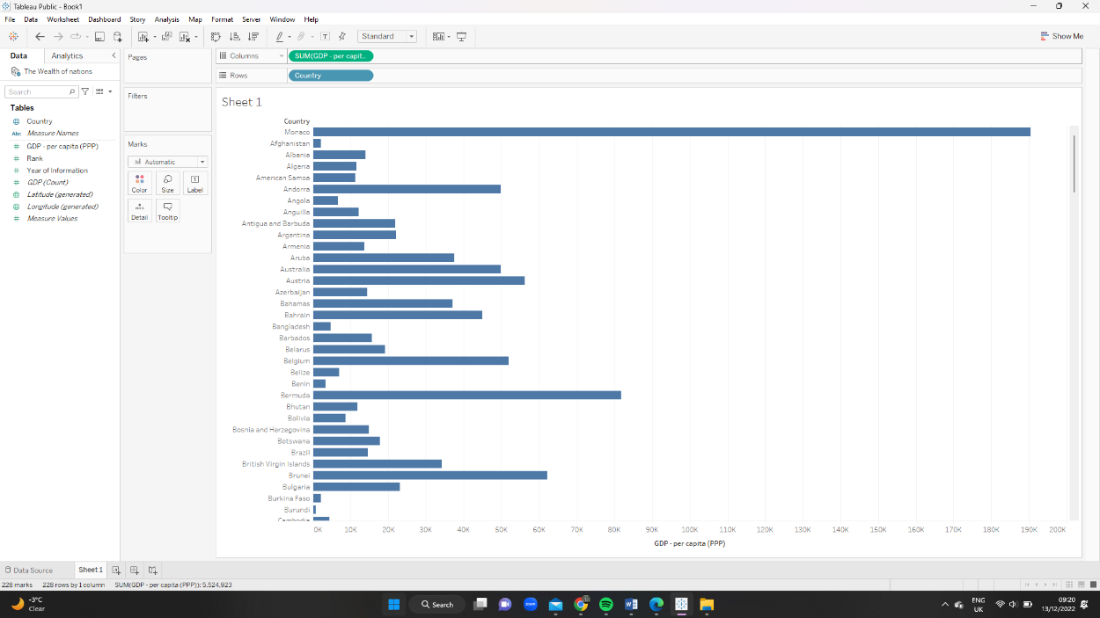Before After

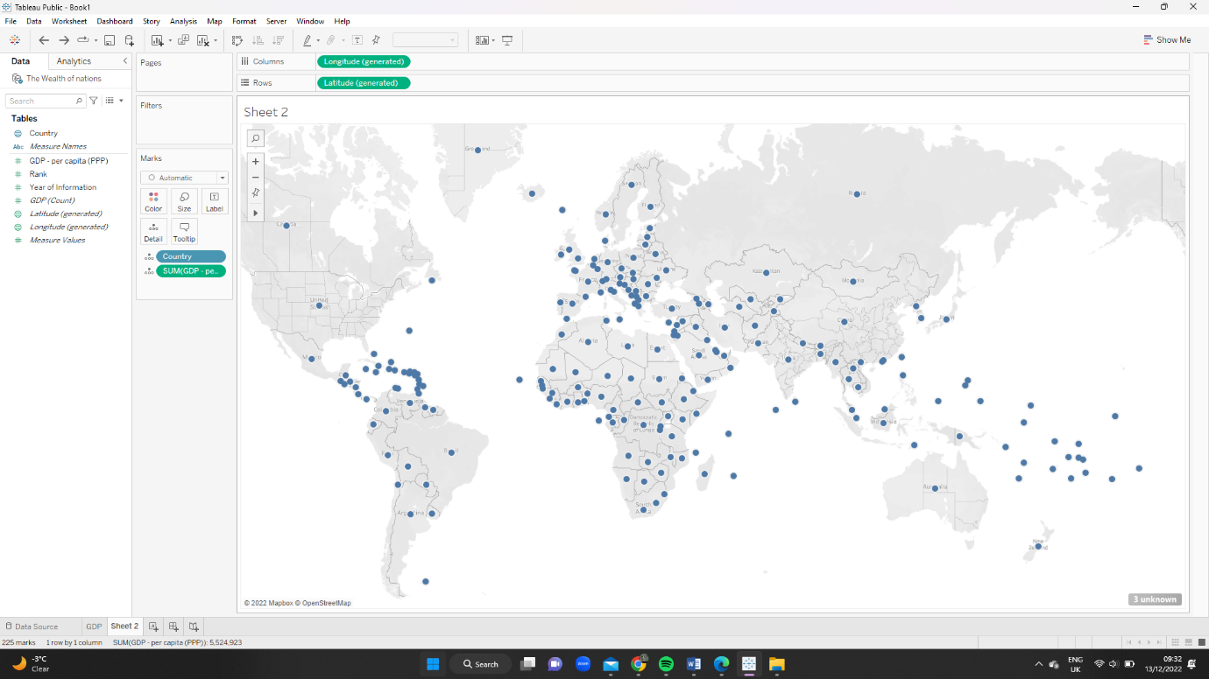

This in this sheet made a geographical graph. To create this graph you need to move the country and sum to marks

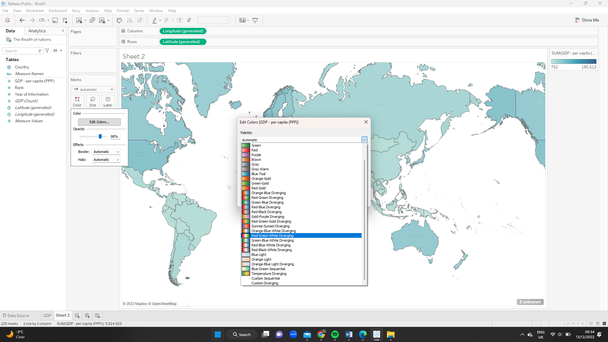

This in screenshot you can see the colour changing. The colour show the min and max by the shade of the colour.

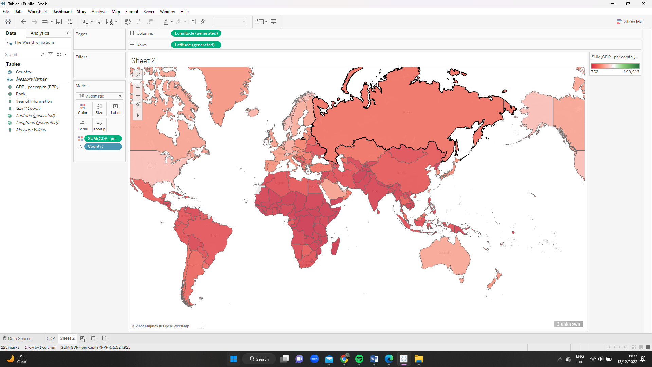

**Dashboard**

A dashboard is a collection of several views, letting you compare a variety of data simultaneously. For example, if you have a set of views that you review every day, you can create a dashboard that displays all the views at once, rather than navigate to separate worksheets.

**Before After**

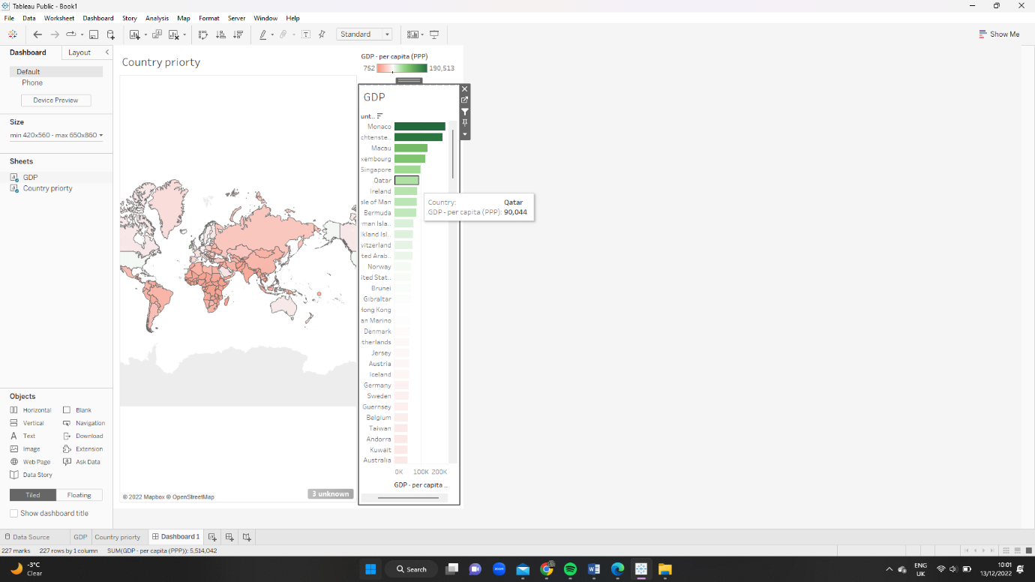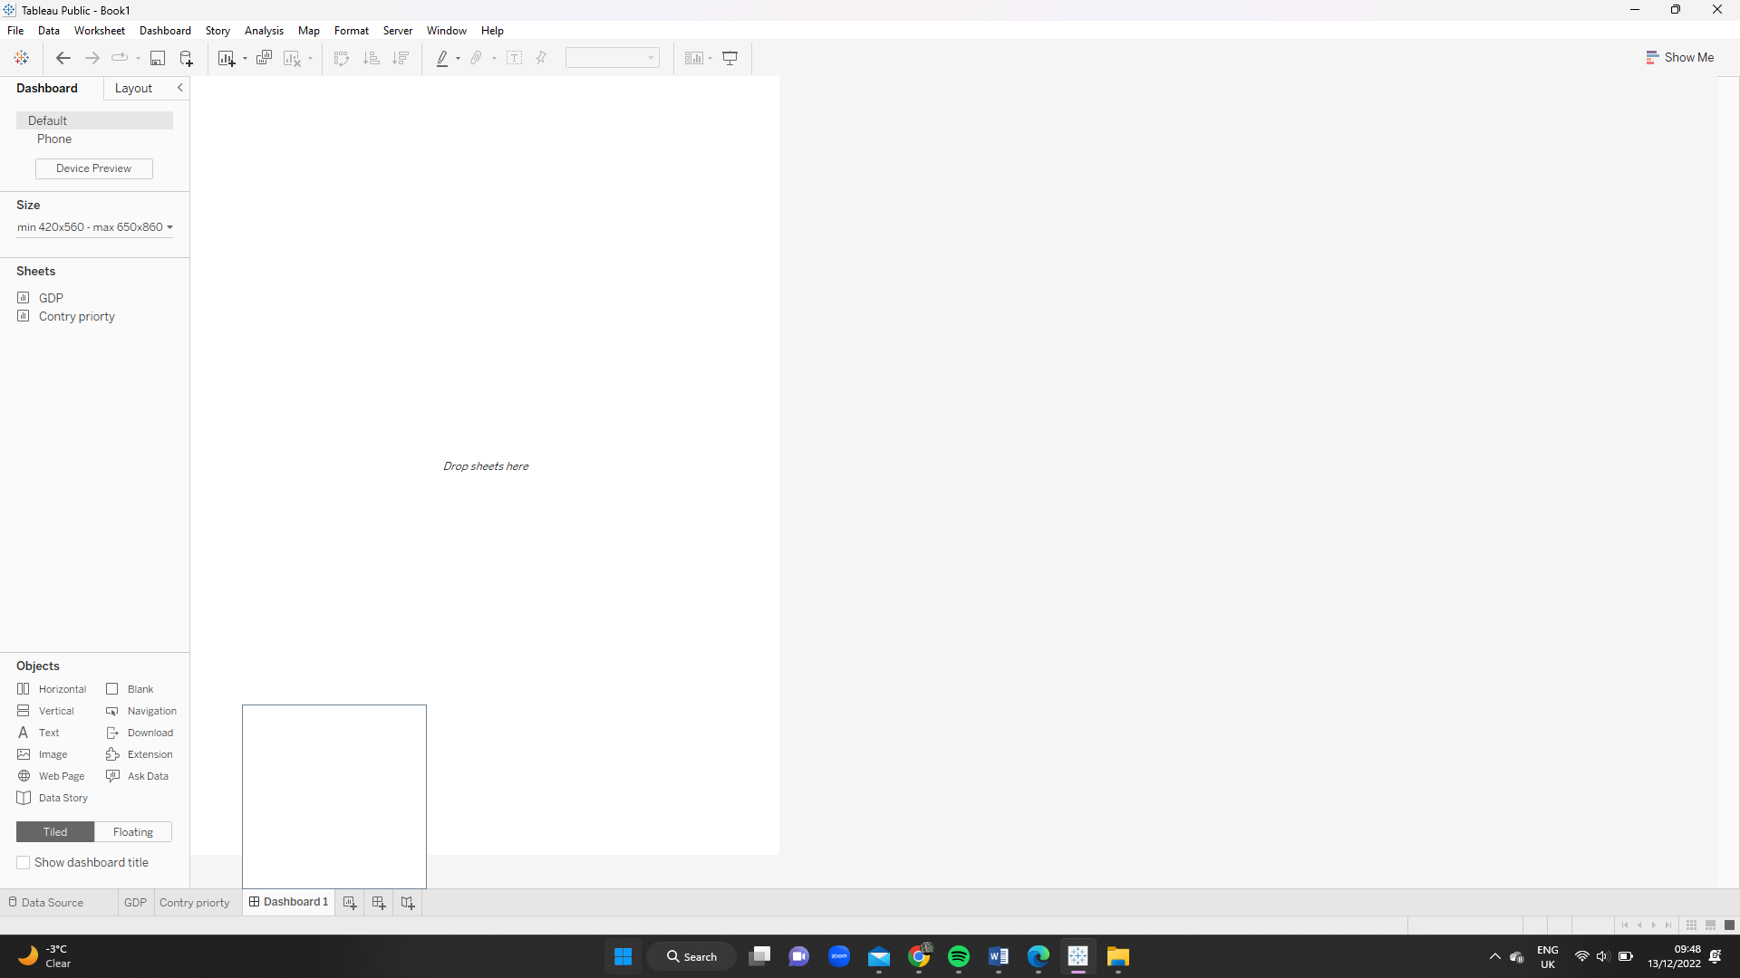

You can add all the graphical data created in the dashboard.

# **Task 4: Introduction to Dashboards using Power BI**

In this task, we will look into creating a dashboard using Microsoft Power Bi. Power BI Is owned by Microsoft and it stand for Power Business Intelligence. With the support of Power BI, I was able to link to a range of data sources, visualize the data in dashboards and reports, and then share it with everyone who works with me.

**What is power BI?**

Power BI is a group of apps, connectors, and software services that combine to turn the various sources of data into logical, visually appealing, and interactive insights. The information may be stored in a hybrid data warehouse that is both cloud-based and within the premises, or it could be an Excel spreadsheet.

Power BI Function

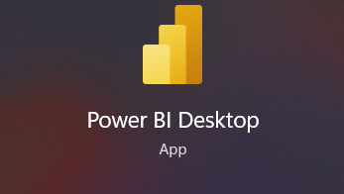

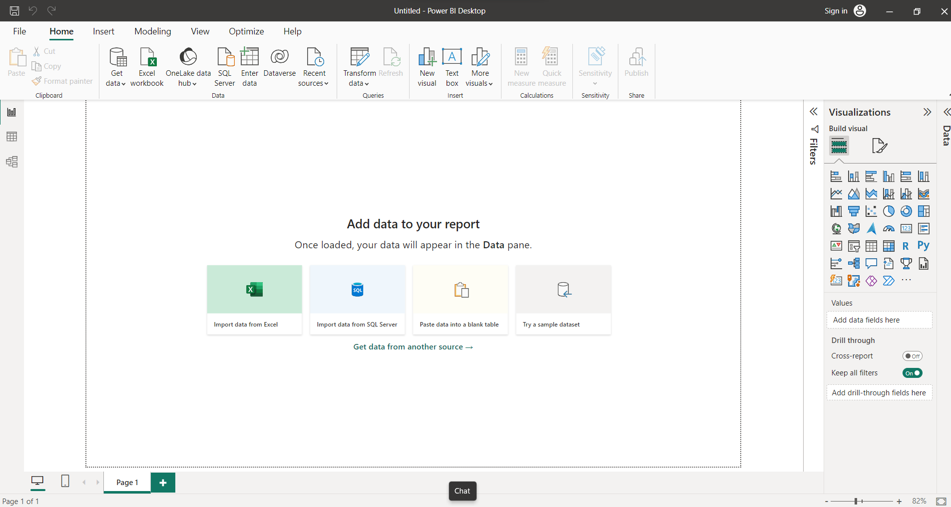

This is how it looks when you open Power BI.

You can extract reports from various source highlighter on the data pane.

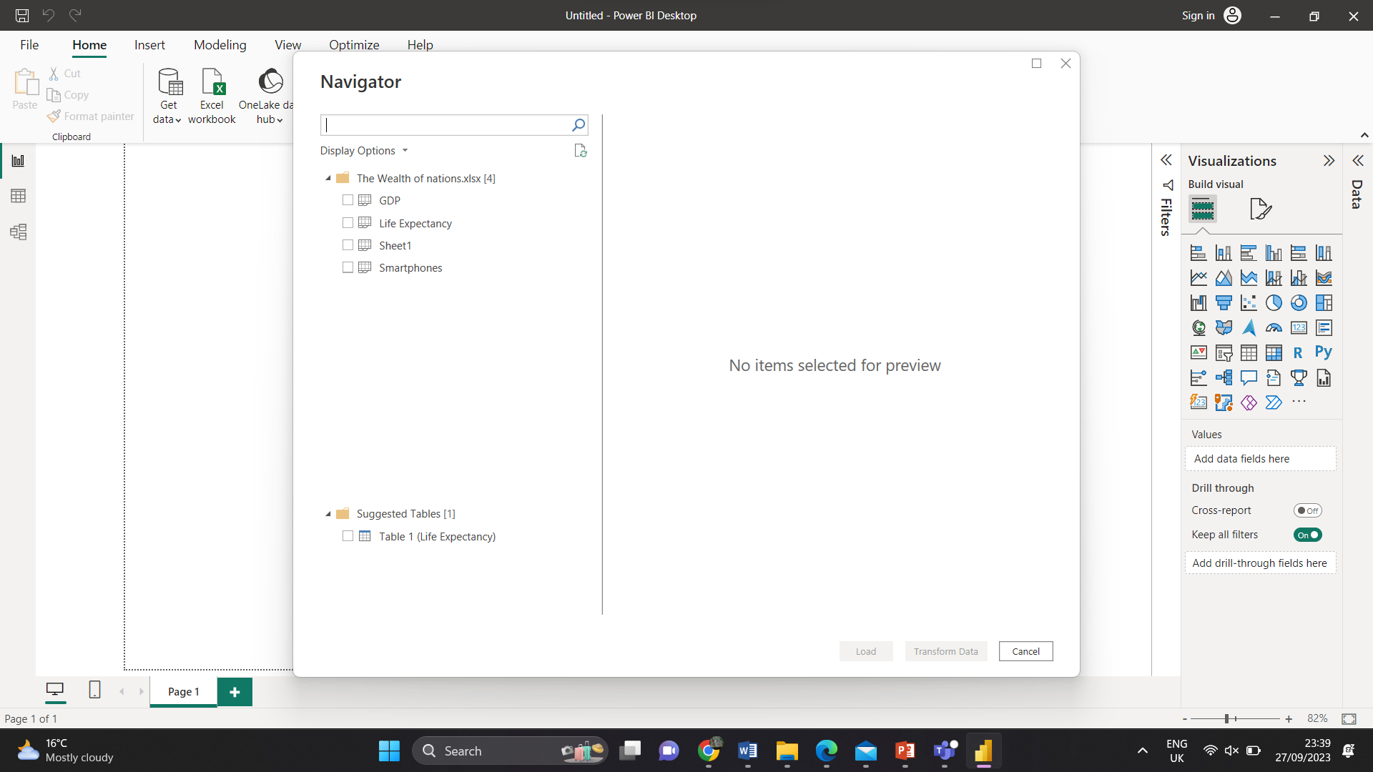

This is the navigator - where you selected the page or sheet you would like to build a visual report for your dashboard

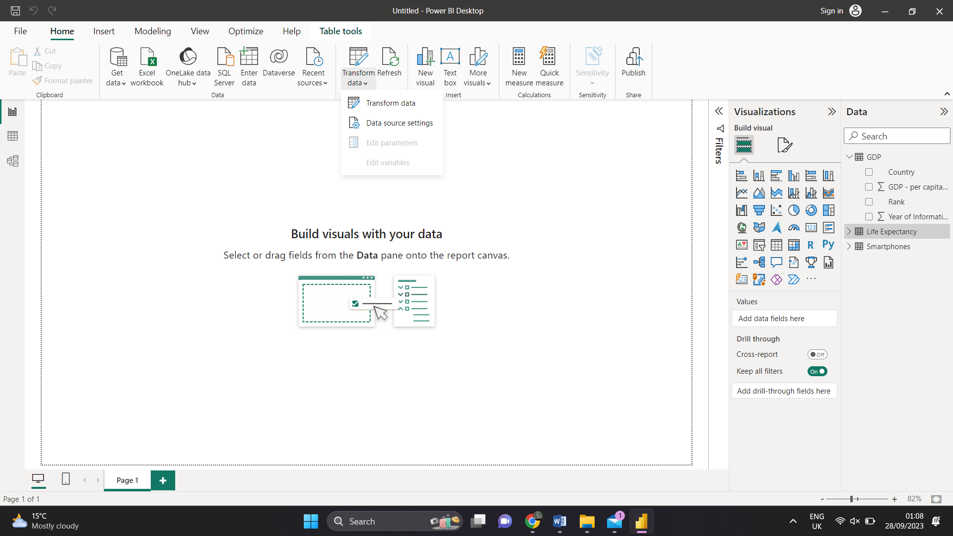

This is the Build visual where you can build the visual. I have went to transform data.

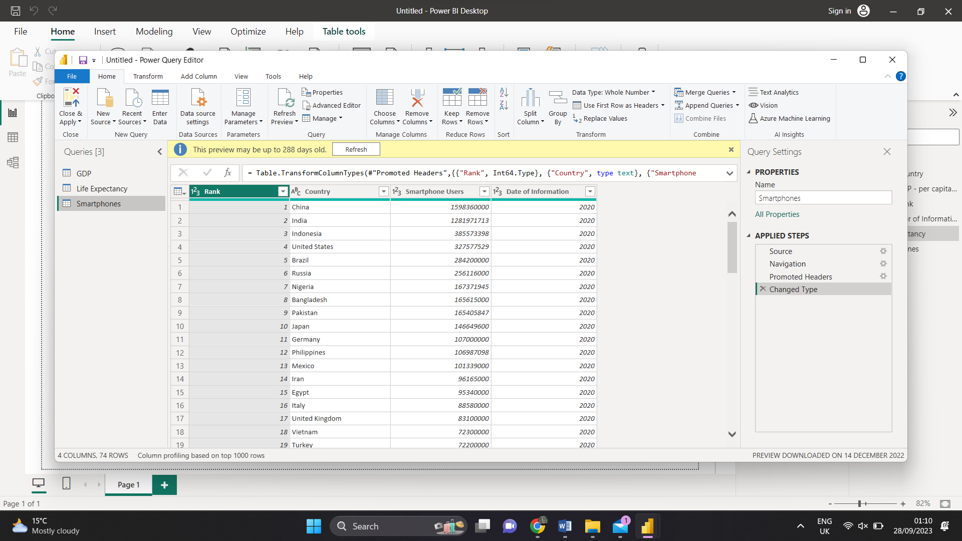

I can now see the table that I transform from power query - Excel

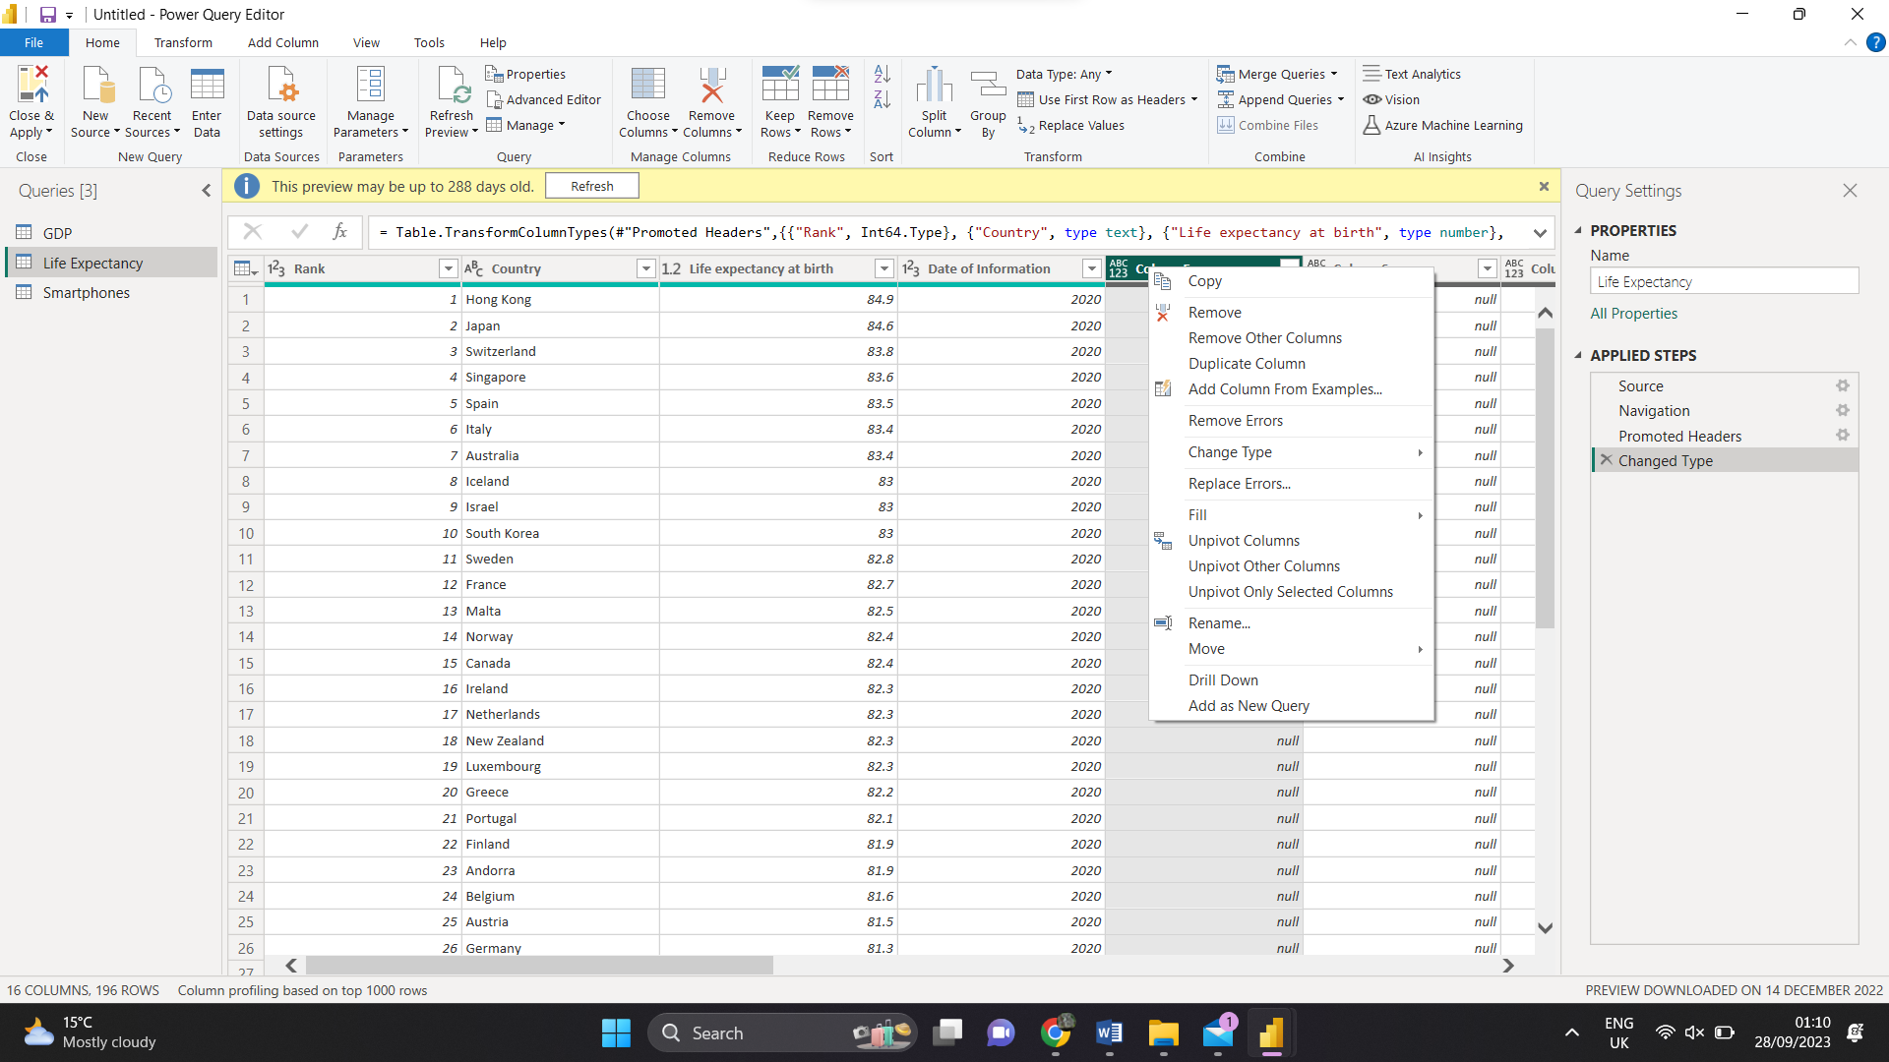

If I right click, I can edit the source or data table

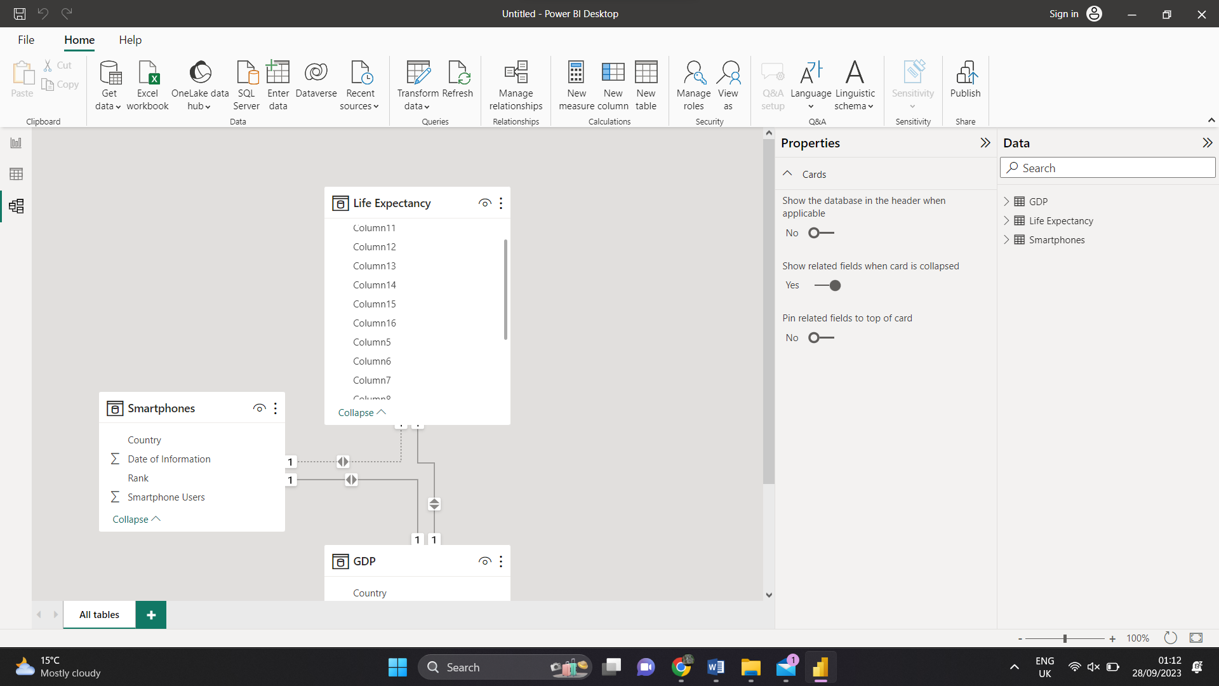

When you have group the data the power BI can see what is the report have in common and help create the visual dashboard

This allows you to group the data

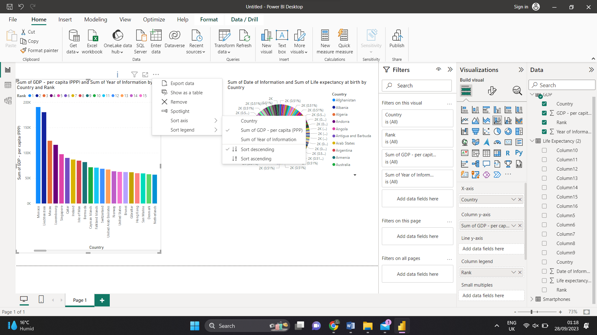

You first need tick the data you would like. Then drag and dropping the centre of the dashboard

You can filter it so that client can knows more about the data.

Desktop view Smartphone view

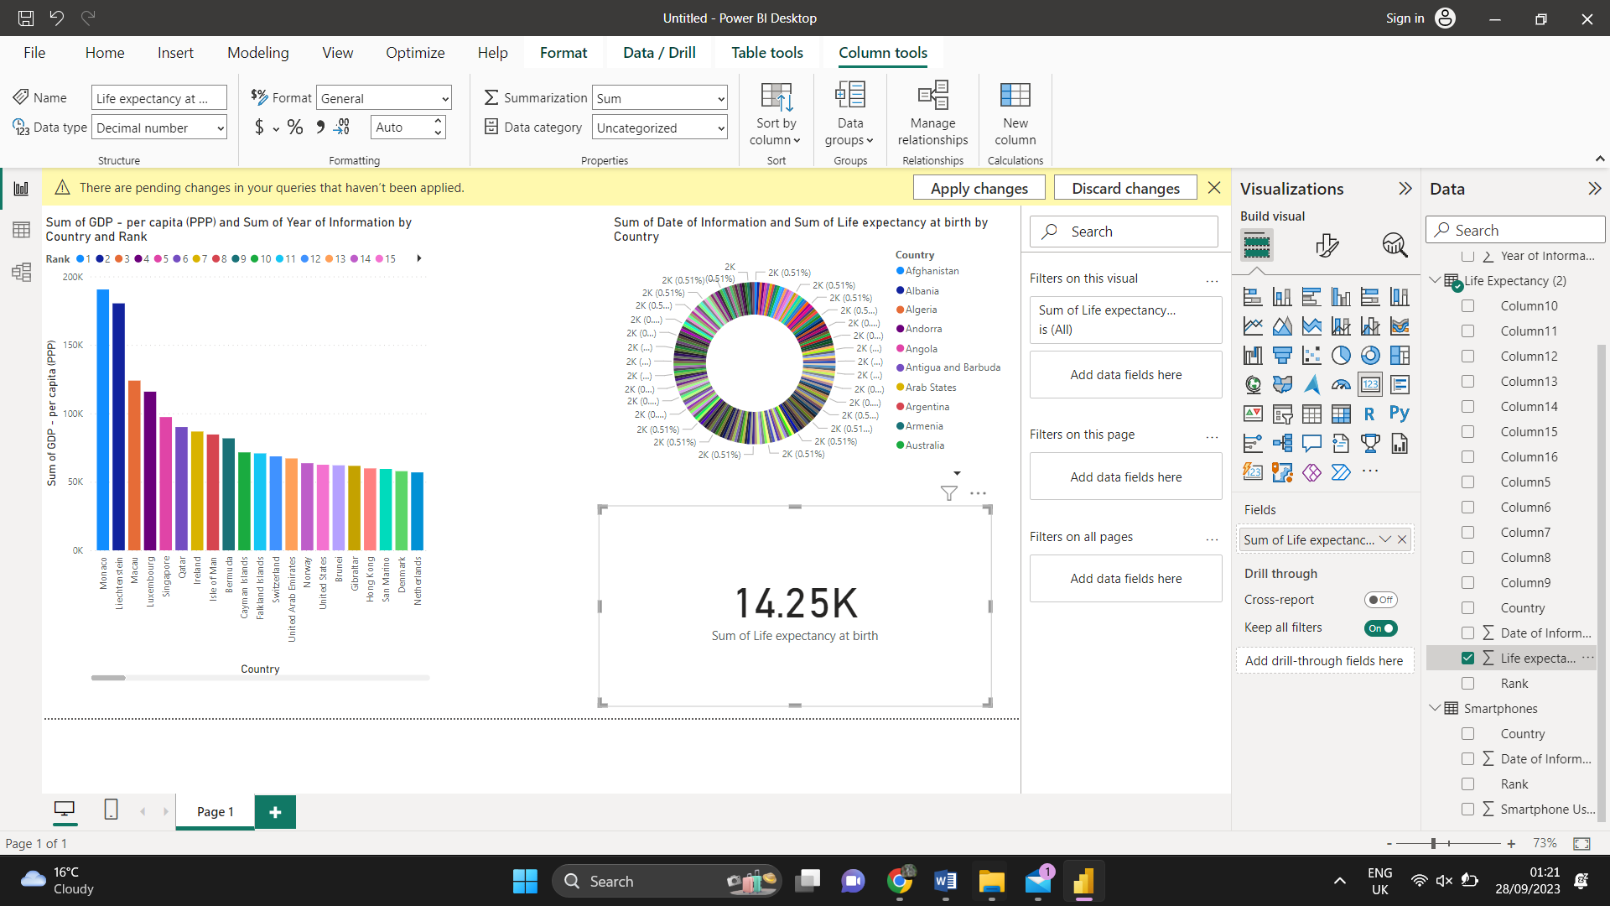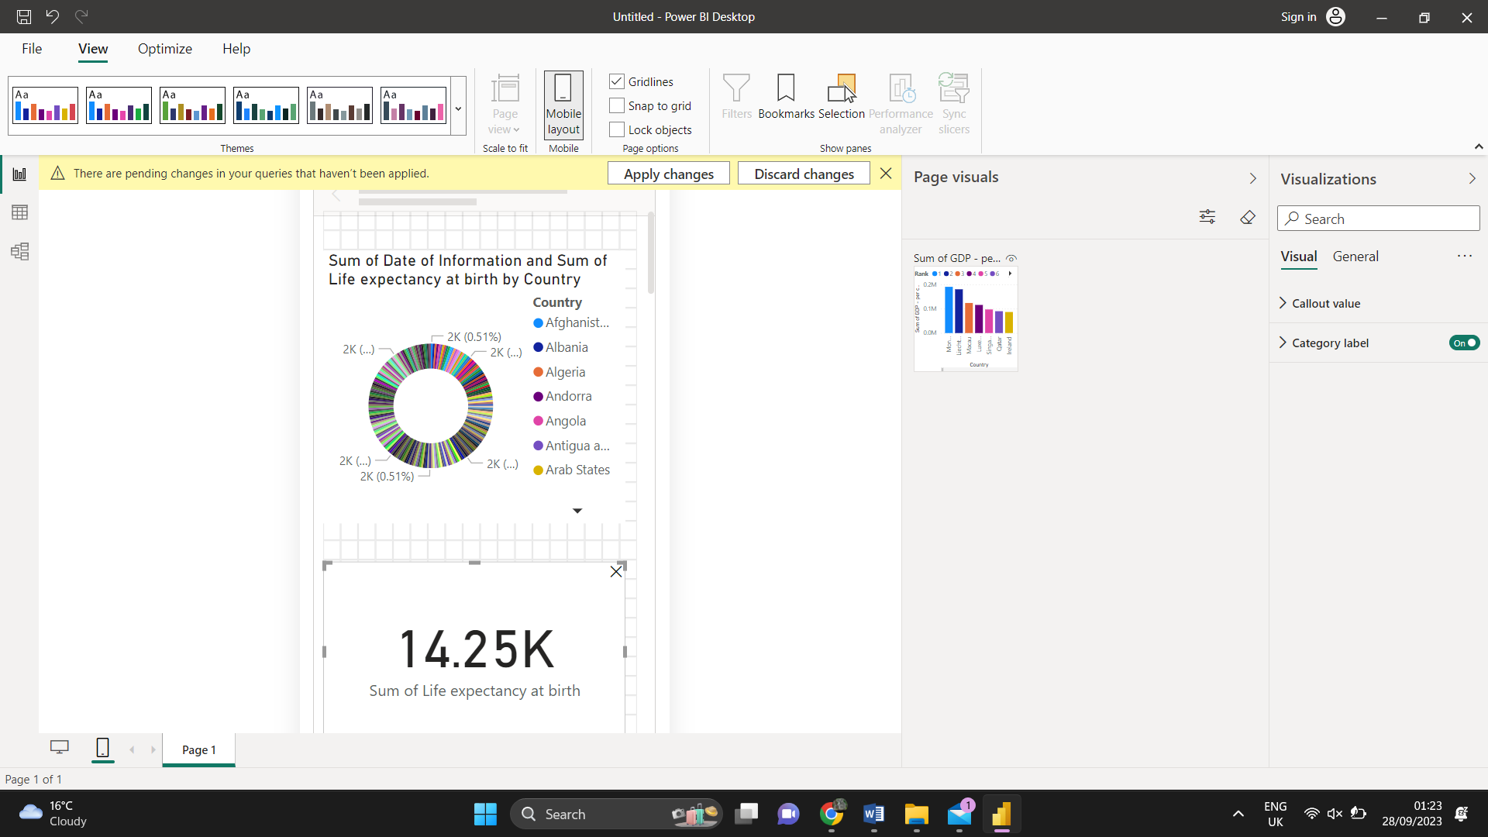

# Conclusion

In conclusion of our analysis of various methods for gathering, storing, and reporting data, many businesses rely on the information to enhance their goods and services.

Data visualization has become an essential business ability that may help transform data into insights that can produce significant company results and improve customer experiences. Many firms now have access to a wealth of data from various areas of their operations, but they are unable to understand how this data could improve decision-making, actions, and results.

We now have a clear understanding of the purpose of data making use thanks to this data.

# References

Induction

<https://www.majesteye.com/why-is-data-important-for-your-business/#:~:text=Data%20helps%20companies%20predict%20trends,businesses%20to%20grow%20and%20prosper>.

Legislation

[General Data Protection Regulation (GDPR) Definition and Meaning (investopedia.com)](https://www.investopedia.com/terms/g/general-data-protection-regulation-gdpr.asp)

Task 1: Data and Data Structures

<https://emerginged.com/blogs/emerginged-blog/eight-data-structures-every-programmer-has-to-know?ga_client_id=GA1.2.1753819506.1666704474&viewId=emergingedl9o8t78gf5wqjm>

Task 2: Development of Data sets using Excel

<https://support.microsoft.com/en-us/office/present-data-in-a-chart-58516b99-55fc-4f45-ac81-cc6868a18a8a#:~:text=Charts%20are%20used%20to%20display,between%20different%20series%20of%20data.&text=Excel%20supports%20many%20types%20of,are%20meaningful%20to%20your%20audience>.

Task 3: Introduction to Tableau

Task 4: Introduction to Dashboards using Power Bi

Conclusion